



Louisiana State University
Industrial Training & Assessment Center

Energy, Waste, and Productivity Assistance for Industry
A U.S. Department of Energy Sponsored Program

Assessment Report

Report No.: LS2521
Location: Baton Rouge, LA
Principal Products: Storage Tank
SIC Number: 3443
Visit Date: 10/13/2025

Dr. Jonathan Shi – Director | Mysha Ahmed – Student Lead
Dr. Chao Wang – Assistant Director | Md Enamul H Moni – Safety Lead
Mrs. Chandler Hayes – Assistant Director | Emily Nelson – Student Engineer
Dr. Michael Hayes – Assistant Director | Marissa Hudgins – Student Engineer
Ravon McKinney – Student Engineer
Tara Bui – Student Engineer
Keana Howard – Student Engineer

Louisiana State University - Industrial Training & Assessment Center (LSU-ITAC)
College of Engineering
3319 Patrick F. Taylor Hall, Baton Rouge, LA
Phone: (225) 578-8652
PREFACE

The work described in this report was performed by the Louisiana State University-Industrial Training & Assessment Center (LSU-ITAC) at the Louisiana State University under contract with the Office of Manufacturing and Energy Supply Chains (MESC) of the U.S. Department of Energy. The ITAC program is managed by the Center for Advanced Energy Systems, Rutgers University, Piscataway, NJ, under contract with the U.S. Department of Energy.

The objective of the ITAC program is to identify and evaluate opportunities for energy efficiency improvements through visits to industrial facilities. The evaluation process is based on the data gathered during a one-day site visit and is thereby affected in detail and completeness by limitations on time at the site. In cases where assessment recommendations (ARs) involving engineering design and capital investment are attractive to the company, it is recommended that the services of a consulting engineering firm be engaged (when in-house expertise is not available) to do detailed engineering design and to estimate implementation costs. Comments regarding this assessment report and information about plans to implement the ARs identified are solicited.

In this assessment, all students visited the facility and provided their technical assessment through field observation, and discussions with the facility personnel, and they also participated in developing the final assessment report. For this report, Mysha Ahmed was the Student Lead who led the facility visit and report writing, Md Enamul H Moni was the Safety/Equipment Lead, and Emily Nelson, Marissa Hudgins, Ravon McKinney, Tara Bui and Keana Howard were the Student Engineers who followed the student lead and faculty’s instruction.

DISCLAIMER

The contents of this report are offered as guidance. Rutgers University (the State University of New Jersey), Louisiana State University, and all technical sources referenced in the report do not (a) make any warranty (expressed or implied) with respect to the accuracy, completeness, or usefulness of the information contained in this report; (b) represent that the use of any information, apparatus, method, or process disclosed in this report will not infringe on privately owned rights; or (c) assume any liabilities with respect to the use of, or for damages resulting from the use of, any information, apparatus, method, or process disclosed in this report. This report does not reflect official views or policies of the abovementioned institutions. Mention of trade names or commercial products does not constitute endorsement or recommendation of use.

Table of Contents

1 EXECUTIVE SUMMARY 6
1.1 General Information 6
1.2 Annual Energy Usages and Costs 6
1.3 Carbon Footprint 6
1.4 Summary of Best Practices and Assessment Recommendations 7
2 GENERAL FACILITY BACKGROUND 10
2.1 Facility Description 10
2.2 Process Description 10
2.3 Historical Energy Usage 11
2.4 Major Energy Consuming Equipment and Devices 13
3 CURRENT BEST PRACTICES 14
3.1 Implementation of Metal Scrap Recycling 14
3.2 Implementation of Pallet Recycling 15
3.3 Partial Implementation of LED light 15
3.4 Implementation of Lean Manufacturing 16
4 RECOMMENDATIONS (ARs) 17
4.1 AR No. 1 – Install Programmable Thermostats 17
4.2 AR No. 2 – Install Sensors for Efficient Light Management 22
4.3 AR No. 3 – HVAC Tune-Up to Increase Energy Efficiency 27
4.4 AR No. 4 – Utilize Higher Efficiency Lamps and/or Ballasts 31
4.5 AR No. 5 – Clean or Color Roof to Reduce Solar Load 37
4.6 AR No. 6 – Replace Existing CNC Press Machines with More Suitable Substitutes 42
4.7 AR No. 7 – Use Solar Heat to Generate Electricity 46
5 THE INDUSTRIAL CONTROL SYSTEMS CYBERSECURITY ASSESSMENT 51

Table of Figures

Figure 2-1. The Satellite View of the Facility 10
Figure 2-2. The Production Process Flowchart 11
Figure 2-3. Monthly Electricity Cost 11
Figure 2-4. Monthly Electricity Usage 12
Figure 2-5. Monthly Demand Charge 12
Figure 2-6. Monthly Demand Usage 12
Figure 2-7. The Major Power Consumers 13
Figure 3-1.Metal Scrap Recycling in the Facility 14
Figure 3-2. Pallet in the Facility 15
Figure 3-3 Partial Implementation of LED lights. 15
Figure 3-4 Lean Manufacturing Benefits 16
Figure 4-1. Thermostat Unit in the Facility. 17
Figure 4-2. The Cooling Hour Count for the Cooling Unit Set at 75°F 18
Figure 4-3. The Cooling Hours Count Based on 75 – 80°F in a Proposed Schedule 19
Figure 4-4. Daylight Sensor and Occupancy Sensor 25
Figure 4-5. Some of the HVAC Units 27
Figure 4-6. Recommended LED Lighting Types 35
Figure ‎4-7. The Concept of the Cool Roof Coating 37
Figure ‎4-8. Input Data to Estimate Cool Roof Potential Energy Savings. 38
Figure ‎4-9. Output from Cool Roof Energy Saving Calculator. 39
Figure ‎4-10. Acrylic Roof Coating with the highest reflectance and UV resistant26F 41
Figure 4-11. The CNC turning machine at the warehouse 42
Figure 4-12. Facility Space 46
Figure 4-13. Theoretical Maximum System Capacity 47
Figure 4-14. The System Specifics Inputs 47
Figure 4-15. The Yearly Solar Savings Results 48

List of Tables

Table ‎1-1. The Facility Energy and Material Usage Summary 6
Table ‎1-2. The Carbon Footprint of the Facility 6
Table ‎1-3. The Assessment Recommendation Summary Table 9
Table 2-1. Operating Hours and Shift Schedule 10
Table 2-2. The Major Power-Consuming Equipment 13
Table 4-1. The Savings Summary for AR No. 1 17
Table 4-2. The Recommended Settings for Cooling Setpoints 19
Table 4-3. The Implementation Cost Summary for AR No. 1 21
Table 4-4. The Savings Summary for AR No. 2 22
Table 4-5. The Summary of Existing Lighting Equipment in the Facility 23
Table 4-6. The Implementation Cost Summary for AR No. 2 26
Table 4-7. The Savings Summary for AR No. 3 27
Table 4-8. The Summary of Old HVAC Units in the Center 27
Table 4-9. The Implementation Cost Summary for AR No. 3 30
Table 4-10. The Savings Summary for AR No. 4 31
Table 4-11. The Summary of Existing Lighting Equipment in the Facility 32
Table 4-12. The Summary of Recommended Lighting Equipment in the Facility 32
Table 4-13. The Implementation Cost Summary for AR No. 4 36
Table ‎4-14. The Savings Summary for AR No. 5 37
Table ‎4-15. The Implementation Cost Summary for AR No. 5 41
Table 4-16. The Savings Summary for AR No. 6 42
Table 4-17. The Savings Summary for AR No. 7 46
Table 4-18. The Implementation Cost Summary for AR No. 7 49
Table 5-1. Industrial Control Systems Cybersecurity Assessment Details 51

EXECUTIVE SUMMARY
Report No.: LS2521

General Information

SIC. No.: 3443 | Annual Production: 40 tanks/year
NAICS Code: 332420 | Annual Sales: $7 million
Principal Product: Bolted Storage Tank | Value per Finished Product: $175,000/tank
No. of Employees: 35 | Total Energy Usage: 3,655 MMBTU/yr
Total Facility Area: 34,725 ft² | Total Utility Cost: $111,092/yr
Operating Hours: 2,340 hrs/yr | No. of Assessment Recommendations: 7

Annual Energy Usages and Costs
Energy usage and the corresponding costs at the facility during the twelve-month period between August 2024 and July 2025 are summarized in Table ‎1-1:

Table ‎1-1. The Facility Energy and Material Usage Summary
Type | Usage | Cost | Unit Cost
Electrical Energy | 439,218 kWh/yr  (1,499 MMBTU/yr) | $37,801/yr | $0.086/kWh
Electrical Demand | 2,337 kW/yr | $40,874/yr | $17.490/kW
Natural Gas | 997 MMBTU/yr | $14,175/yr | $14.218/MMBTU
Water | 3,102 Tgal/yr | $2,442/yr | $0.787/Tgal
Diesel Gas | 316 MMBTU/yr | $5,900/yr | $18.671/MMBTU
Propane Gas | 843 MMBTU/yr | $9,900/yr | $11.744/MMBTU
Total Utility | 3,655 MMBTU/yr | $111,092/yr | -

Carbon Footprint
Based on the facility's energy consumption and regional averages (Entergy's Climate Scenario Analysis0F and Carbon Dioxide Emissions Coefficients1F) for carbon dioxide emissions associated with this energy release, the plant's current carbon footprint can be calculated with the results as shown in Table ‎1-2:
Table ‎1-2. The Carbon Footprint of the Facility
Electricity | 168 | Tons CO₂/yr
Natural Gas | 58 | Tons CO₂/yr
Propane Gas | 53 | Tons CO₂/yr
Diesel Gas | 24 | Tons CO₂/yr
Total | 303 | Tons CO₂/yr

Summary of Best Practices and Assessment Recommendations

The assessment team has found four best practices and seven areas for potential improvements at the facility. Detailed descriptions of the best practices are presented in Section 3 of this report. The best practices observed are listed as follows:

- Implementation of Metal Scrap Recycling
- Implementation of Pallet Recycling
- Partial Implementation of LED Light
- Implementation of Lean Manufacturing

The seven Assessment Recommendations (ARs) together represent the total cost savings of $128,639/yr. The total implementation cost is estimated at $1,251,945, yielding an average payback of 10.76 years. If all ARs are implemented, these measures will result in an annual reduction of 303 tons/yr in carbon dioxide emissions, and 547,775 kWh of electricity. Detailed analysis and savings calculations of the ARs are provided in Section 4 of this report. The ARs are summarized as follows with their key savings information as listed in Table ‎1-3:

AR No. 1 – Install Programmable Thermostats
- Installing and correctly scheduling programmable thermostats in office and conditioned areas will help minimize unnecessary HVAC operation during unoccupied periods. This energy conservation measure provides annual cost savings of $1,212, requires an estimated implementation cost of only $25, and achieves a simple payback of 0.02 years. The measure is expected to reduce electricity use by roughly 14,096 kWh per year and lower CO₂ emissions by 5 tons annually.

AR No. 2 – Install Sensor for Efficient Light Management
- Installing occupancy sensors in appropriate office, warehouse, and low-occupancy areas will automatically turn lights off when spaces are unoccupied. This measure yields annual cost savings of $796 from electricity reductions of approximately 9,256 kWh/year, with an implementation cost of $300 and a simple payback of 0.38 years. The reduced lighting energy use corresponds to a CO₂ reduction of about 4 tons/year.

AR No. 3 – HVAC Tune Up to Increase Energy Efficiency
- Performing a comprehensive tune-up of the HVAC system covering coil cleaning, refrigerant charge verification, airflow adjustments, and general mechanical inspection can significantly improve operational efficiency and reduce cooling energy demand. This measure provides an estimated annual cost savings of $746 and does not require major capital expenditures beyond routine maintenance labor, resulting in a very short payback period. The tune-up is projected to lower electricity use by roughly 8,676 kWh per year, contributing to an annual reduction of approximately 3 tons of CO₂ emissions.

AR No. 4 – Utilize Higher Efficiency Lamps and/or Ballasts
- Upgrading to higher efficiency lamps and ballasts will improve lighting performance while lowering electricity consumption throughout the facility. Replacing older lighting with modern high-efficiency alternatives requires minimal capital investment and reduces ongoing energy costs. This measure provides estimated annual cost savings of $2,368, with an implementation cost of about $2,575, resulting in a simple payback period of approximately 1.09 years. The upgrade is expected to reduce electricity use by roughly 13,498 kWh per year and lower CO₂ emissions by about 7 tons annually.

AR No. 5 – Clean/Color Roof to Reduce the Solar Load
- Cleaning the roof surface and applying a high-reflectance coating will reduce solar heat gain and lower cooling demand within the building. A reflective roof helps maintain lower indoor temperatures, allowing HVAC systems to operate more efficiently. This measure provides estimated annual cost savings of $3,125, with an implementation cost of approximately $12,153, resulting in a simple payback period of about 3.88 years. The improved roof reflectivity is expected to reduce electricity use by roughly 36,337 kWh per year and decrease CO₂ emissions by about 14 tons annually.

AR No. 6 – Replace Existing CNC Machines with More Suitable Substitutes
- Replacing older, less efficient CNC machines with modern, properly sized equipment will reduce both electricity use and maintenance costs while improving productivity. This productivity and energy measure yields annual cost savings of $70,474, with an implementation cost of $710,000, resulting in a simple payback of 10.07 years. The upgrade also leads to an estimated CO₂ emissions reduction of around 10 tons/year through lower electricity consumption.

AR No. 7 – Utilize Solar Heat to Generate Electricity
- Using solar heat to generate electricity on-site will allow the facility to produce its own clean, renewable energy, reducing its reliance on the grid and lowering energy costs. This renewable energy measure will yield annual cost savings of $37,653, with an implementation cost of $526,500. The project features a payback period of 13.98 years, a CO₂ emissions reduction of 167 tons/year, and will generate savings of approximately 437,832 kWh of electricity per year.

Table ‎1-3. The Assessment Recommendation Summary Table
AR No. | Category | Description | Electricity Savings (kWh/yr) | Energy Cost Savings ($/yr) | Operational Cost Savings ($/yr) | Demand Savings  (kW/yr) | Demand  Cost ($/yr) | Total Cost Savings ($/yr) | CO₂ Reduction (Tons/yr) | Impl.  Cost ($) | Payback Period  (yrs)
1 | Space Conditioning | Install Programmable Thermostat | 14,096 | 1,212 | - | - | - | 1,212 | 5 | 25 | 0.02
2 | Building & Grounds | Install Sensor for Efficient Light Management | 9,256 | 796 | - | - | - | 796 | 4 | 300 | 0.38
3 | Space Conditioning | HVAC Tune up to Increase Efficiency | 8,676 | 746 | - | - | - | 746 | 3 | 392 | 0.53
4 | Building & Grounds | Utilize Higher Efficiency Lamps/or Ballasts | 13,498 | 1,161 | - | 69 | 1,207 | 2,368 | 5 | 2,575 | 1.09
5 | Building Envelope | Clean or Color Roof | 36,337 | 3,125 | - | - | - | 3,125 | 14 | 12,153 | 3.88
6 | Reduction of Downtime | Replace Existing CNC Press Machine | 28,080 | 2,414 | 68,060 | - | - | 70,474 | 10 | 710,000 | 10.07
7 | Alternative Energy Usage | Use Solar Heat to Generate Electricity | 437,832 | 37,653 | - | - | - | 37,653 | 167 | 526,500 | 13.98
 |  | TOTALS | 547,775 | 47,107 | 68,060 | 69 | 1,207 | 116,374 | 208 | 1,251,945 | 10.76

GENERAL FACILITY BACKGROUND

Facility Description
A satellite view of the 34,725 ft² facility is shown in Figure ‎2-1. The facility has two major areas: a production area and an office area. The facility operates five days a week in one shift with an average of 9 hours/day, and 260 days/yr. Their annual production is 40 tanks per year with annual sales of $7 million. The total number of employees is 35. The facility's operating hours and shifts are summarized in Table ‎2-1.

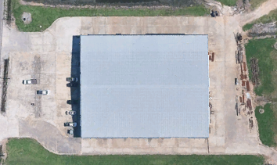
Figure ‎2-1. The Satellite View of the Facility

Table ‎2-1. Operating Hours and Shift Schedule
Department | Shift Start – Shift End | Days/Week | Number of Employees
Production Area | 7 am- 4 pm | Monday-Friday | 35

Process Description
At the facility, the production of bolted steel storage tanks begins with the receiving and inspection of raw materials such as steel plates, structural components, hardware, and industrial coatings. These materials are then processed in the fabrication area, where automated cutting, forming, and welding produce tank panels, roof sections, and accessory structures based on stamped engineering designs. After fabrication, all components move into the surface preparation and coating area, where they are sandblasted, coated with protective systems such as epoxy or galvanized finishes, and inspected for coating quality and durability. The finished parts are then organized into modular field-erection kits, packaged with hardware and installation accessories, and verified against engineering specifications for accuracy and completeness. Once quality checks are completed, the components are palletized, labeled, and prepared for shipment to customer sites, where final assembly and erection occur. The integrated process ensures consistent fabrication, corrosion protection, and efficient field installation for domestic and international tank projects. The process flow is shown in Figure ‎2-2.
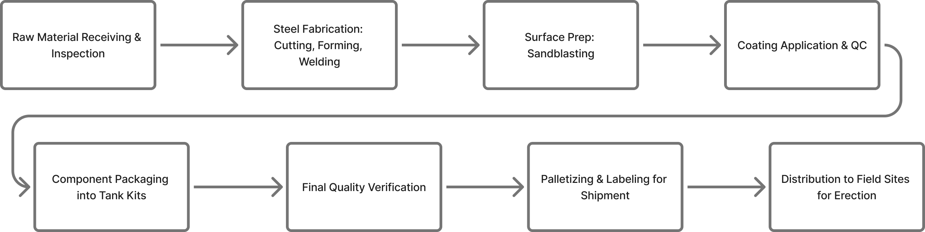
Figure ‎2-2. The Production Process Flowchart

Historical Energy Usage
The client provided monthly electricity costs and electricity usage of the facility for one year, from August 2024 to July 2025, as shown in Figure ‎2-5. The electricity rate is estimated at 8.6 cents per kWh. The following findings can be observed from the figures on electricity usage and information from the site visit:
- The electricity usage (kWh) and cost show different seasonal patterns. Energy Usage peaks in September 2024 and is slowest in the winter months of January-February 2025. However, the highest electricity cost occurs in July 2025, which does not correspond to the highest usage. This may indicate a significant seasonal utility rate increase in July.
- The peak consumption is in September 2024, with usage also high in the surrounding fall months (Aug-Nov 2024). This may indicate peak production at the facility, as major energy-consuming equipment like Hydraulic units and air compressors may consume more energy during peak production.

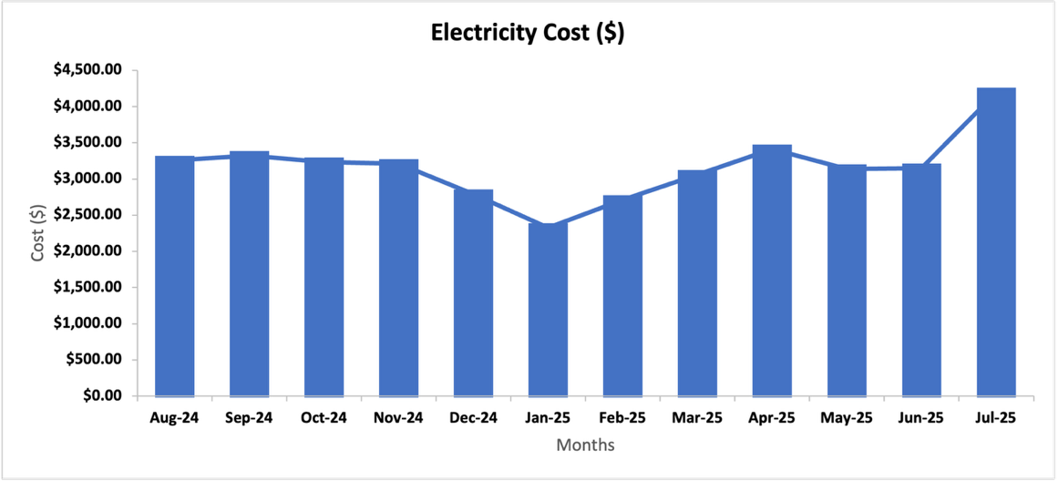
Figure ‎2-3. Monthly Electricity Cost

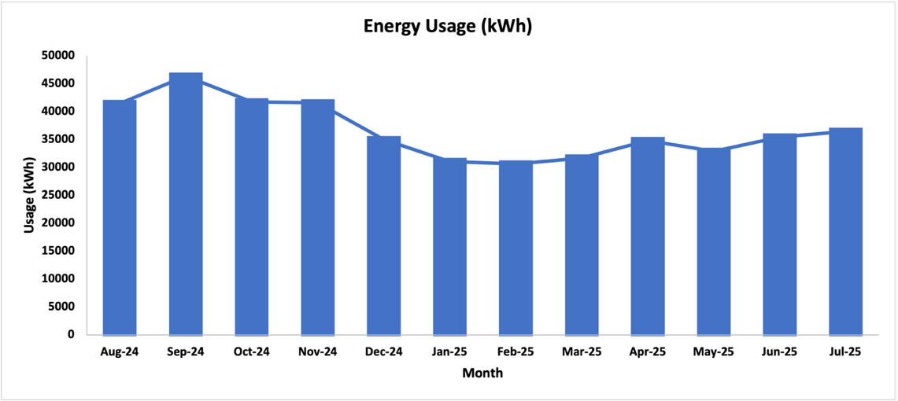

Figure ‎2-4. Monthly Electricity Usage

The facility’s monthly demand costs are plotted in Figure ‎2-5. Figure ‎2-6 demonstrates the monthly demand usage in kW. Based on our analysis, the demand charge is estimated to be $ 17.49 per kW. The highest demand cost and the peak demand usage both occurred in December 2024 and indicate that the demand cost and demand usage (kW) correlate reasonably well.
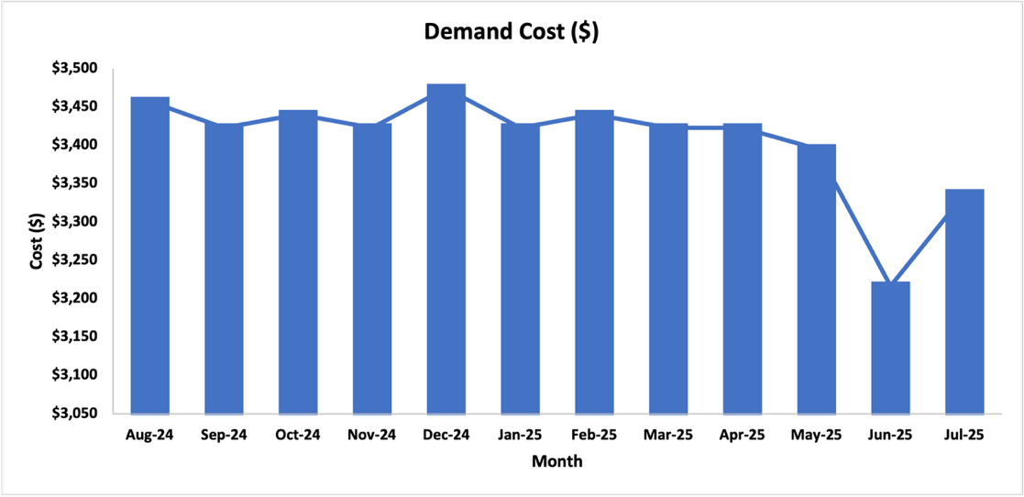
Figure ‎2-5. Monthly Demand Charge

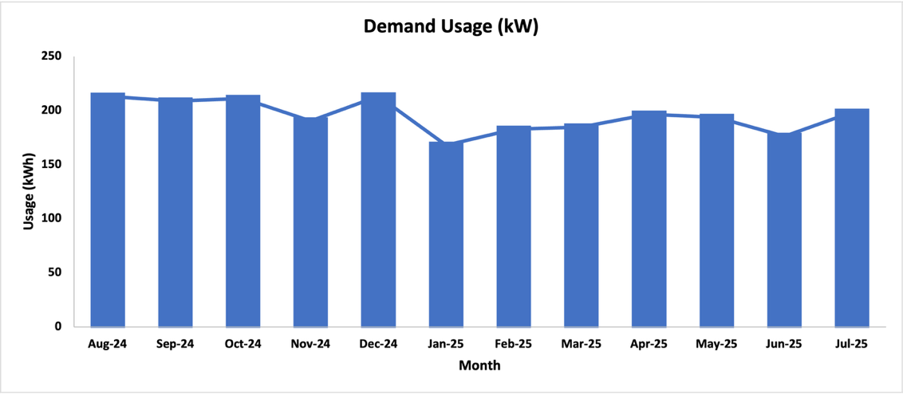
Figure ‎2-6. Monthly Demand Usage

Major Energy-Consuming Equipment and Devices
A list of major equipment and devices is provided in Table ‎2-2. Figure ‎2-7 shows how much power is used by each piece of equipment in the facility. This figure indicates that the air compressor and Hydraulic unit are the primary power consumers in the facility, accounting for approximately 78% of the total power, respectively.

Table ‎2-2. The Major Power-Consuming Equipment
Energy Application | Power (hp) | Quantity | Total Power (hp) | Percentage
Cutting Machine | 20 | 1 | 20 | 10.6%
CNC Punch Press | 34 | 1 | 34 | 18.0%
Welding Machine | 15 | 3 | 45 | 23.8%
Hydraulic Press Brake | 25 | 2 | 50 | 26.5%
Air Compressor | 40 | 1 | 40 | 21.2%
Total |  | 8 | 189 | 100%

Figure ‎2-7. The Major Power Consumers

CURRENT BEST PRACTICES

During the visit and discussion with the facility managers, the LSU-ITAC team found that the facility management team currently employs a few good practices, which are briefly described below.

Implementation of Metal Scrap Recycling
The LSU-ITAC team observed that scrap metal generated from manufacturing processes is systematically collected, segregated, and stored in designated bins for recycling, as shown in Figure ‎3-1 This initiative reflects a strong commitment to sustainable resource management and waste reduction. By diverting this significant waste stream from landfills, the facility minimizes its environmental impact and preserves valuable raw materials. This practice supports a circular economy by reducing the energy required to produce virgin metals. Additionally, this organized approach to scrap management generates revenue from recycled materials and lowers overall waste disposal costs.
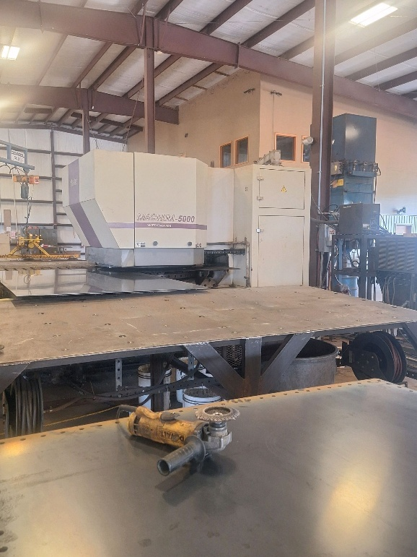
Figure ‎3-1. Metal Scrap Recycling in the Facility

Implementation of Pallet Recycling
The LSU-ITAC team noted that wooden pallets are systematically collected, sorted, and prepared for reuse or recycling throughout the facility, as shown in Figure ‎3-2. Damaged pallets are removed from circulation and either repaired onsite or returned to approved recyclers, ensuring that usable materials remain in the supply chain. This practice minimizes wood waste generation, reduces the need for new pallet purchases, and supports responsible resource management. By extending pallet life cycles and diverting damaged units from disposal, the facility strengthens its commitment to sustainability, decreases operational costs, and promotes a more efficient, circular materials flow.
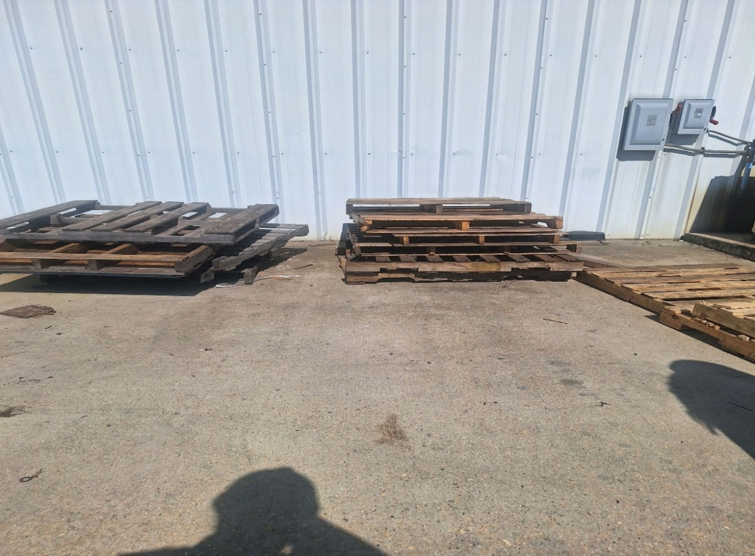
Figure ‎3-2. Pallet in the Facility

Partial Implementation of LED light
The LSU-ITAC team observed that energy-efficient LED lighting has been partially implemented throughout the facility as shown in Figure ‎3-3, with key operational areas and offices being upgraded from older, less efficient systems. This initiative reflects a strong commitment to sustainable energy management. By strategically replacing outdated lighting in high-usage areas, the facility significantly reduces its electricity consumption and operational costs. This targeted approach minimizes the environmental footprint by lowering greenhouse gas emissions. Additionally, the upgraded LED lighting enhances workplace safety and visibility, supports sustainability goals, and allows for a phased investment in energy-efficient technology across the entire operation.
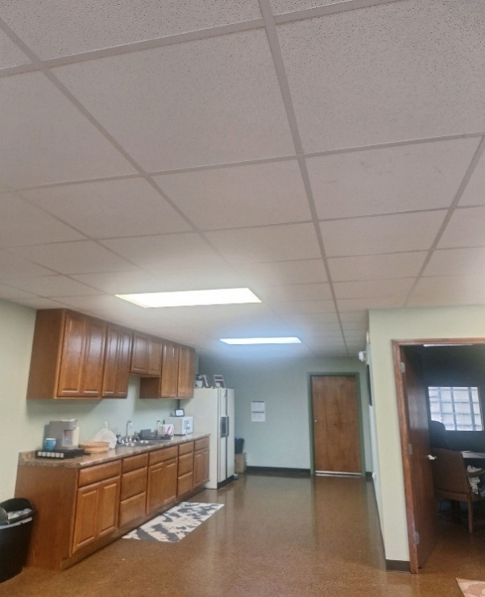
Figure ‎3-3 Partial Implementation of LED lights.

Implementation of Lean Manufacturing
The LSU-ITAC team observed the active implementation of Lean Manufacturing principles, including 5S methodologies, visual management boards, and standardized work procedures in key production areas. This initiative reflects a strong commitment to continuous improvement and operational excellence. By systematically identifying and eliminating waste (such as defects, waiting, and unnecessary motion), the facility significantly improves its production efficiency and product quality. This approach empowers employees by engaging them in problem-solving, which fosters a culture of innovation. Additionally, Lean practices lead to reduced lead times, lower operational costs, and improved workplace safety.
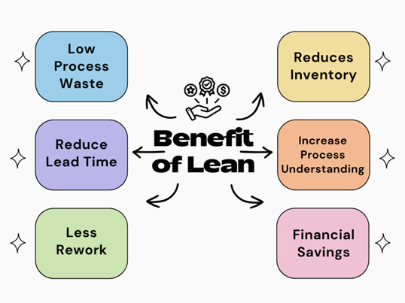
Figure ‎3-4 Lean Manufacturing Benefits

RECOMMENDATIONS (ARs)
This section provides detailed calculations and analyses for the assessment recommendations (ARs).

AR No. 1 – Install Programmable Thermostats
(ARC Code 2.7261)

Table ‎4-1. The Savings Summary for AR No. 1
Energy Savings (kWh/yr) | Energy Cost Savings ($/yr) | Total Cost Savings ($/yr) | CO₂ Reduction (Tons/yr) | Imp. Cost  ($) | Payback Period  (yrs)
14,096 | 1,212 | 1,212 | 5 | 25 | 0.02

Observation and Analysis
LSU-ITAC observed that in the building area, there were four 6-ton cooling units in operation with a total capacity of 24 tons, set at an average temperature of 75°F. These cooling units were controlled by programmable thermostats. According to the management team, the thermostats were kept at a constant temperature. Such control strategies will result in unnecessary energy usage by the cooling unit, since the real-time temperature may still be higher than the set points during the off-hours and weekends. If the facility installs the programmable thermostats in place of the non-programmable thermostats and sets up a temperature schedule on the existing programmable thermostats for the cooling units, there will be energy savings coming from the reduced working hours of the cooling units that otherwise would be working.

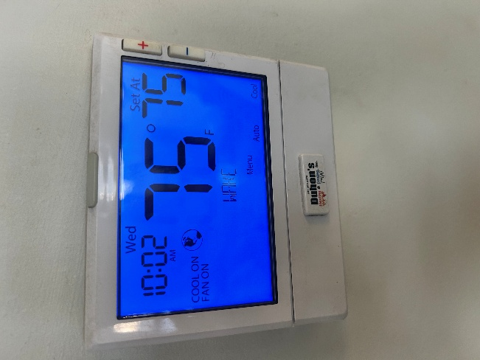
Figure ‎4-1. Thermostat Unit in the Facility.

Recommendation
We recommend that the facility set up a temperature schedule on the existing programmable thermostats. The thermostats should be programmed such that when the office areas are unoccupied, the setpoints should be raised to 80°F, and revert to their current setpoints an hour before the shift begins. When the indoor temperature is below the setpoint, the cooling units will stop operating. By doing so, the total cooling hours and load will be reduced, resulting in noticeable energy and cost savings.

Calculations
Current Electrical Energy Usage
We assume that the indoor temperature equals the outdoor temperature over a year. The current cooling hours were estimated using TMY3 data specific to the local area, using temperature-bin analysis. The hours count for the cooling unit when the indoor air temperature is higher than the setpoints and requires cooling over the year are shown in Figure ‎4-2. The row levels represent the temperature range (°F), and column labels represent the time range of the day (hour) for a 24-hour clock period.

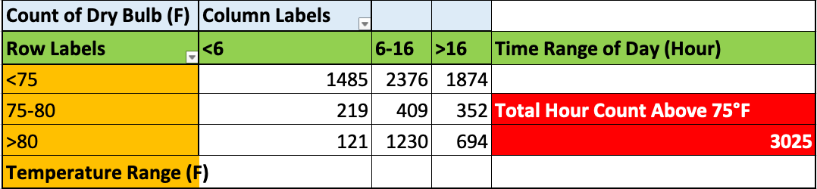
Figure ‎4-2. The Cooling Hour Count for the Cooling Unit is set at 75°F

From the hour count, we know that there generally have been 3,025 hours in a year when the outside temperature was higher than 75°F. Thus, we can calculate the current cooling energy usage of the cooling units as follows:

EU_{CC} = (RC_{T} × CH₇₂ × LF_{C} / COP_{C}) × K_{T}
= ((24ton) × 3,025 hrs/yr × 0.8 / 3.28) × 3.5 kW/ton
= 61,976 kWh/yr,
where
EU_{CC} = Current Cooling Energy Usage, kWh/yr
RC_{T} = Total Rate Capacity of Cooling Units, tons
CH₇₂ = Total Cooling Hours in a Year Based on 75°F
LF_{C} = Estimated Load Factor for Cooling Units, estimated at 0.8
COP_{C} = Cooling Coefficient of Performance, estimated at 3.28
K_{T} = Conversion Factor, 3.5 kW/ton

Proposed Electrical Energy Usage
It is recommended that the cooling units start cooling the office an hour before space begins to be occupied. Choosing the time range to show the cooling hours based on 75 – 80°F that fall into shift hours, we change the pivot table, as shown in Figure ‎4-3.

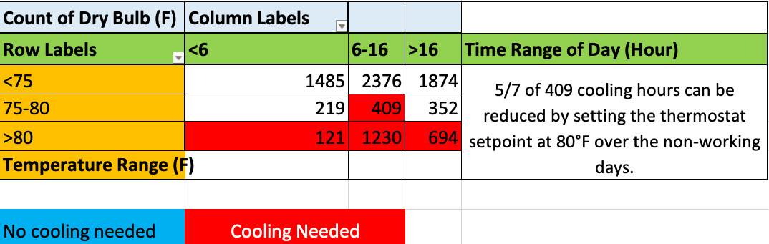
Figure ‎4-3. The Cooling Hours Count Based on 75 – 80°F in a Proposed Schedule
Since there are five workdays in a seven-day week, 5/7 of the 409 cooling hours based on 75 – 80°F that fall into shift hours can be reduced, as it represents non-operational days. Therefore, we estimate that the cooling hours during working hours are as:
CH_{W} = 409 × (1 – 2/7) + 121 + 1,230 + 694
= 2,337 hrs/yr,

where
CH_{W} = Cooling Hours during the Working Hours under Proposed Schedule, hrs/yr
CH_{T} = Total Cooling Hours during Working Hours with Weekends included under the Proposed Schedule, hrs/yr

This new setpoint schedule will result in 2,514 annual cooling hours for the office. The proposed cooling setpoints schedule is summarized in Table ‎4-2.

Table ‎4-2. The Recommended Settings for Cooling Setpoints
Days | Time | Cooling Setpoint | Estimated Cooling Hours per Year
Monday – Friday | 6:00 am – 4:00 pm | Cool: 75°- 80° F | 2,337

The proposed cooling energy usage can be calculated as:
EU_{CP} = (RC_{T} × CH_{P} × LF_{C} / COP_{C}) × K_{T}
= ((24-ton) × 2,337 hrs/yr × 0.8 / 3.28) × 3.5 kW/ton
= 47,880 kWh/yr,

where
EU_{CP} = Proposed Cooling Energy Usage, kWh/yr
RC_{T} = Total Rate Capacity of the Cooling Units, tons
CH_{P} = Total Cooling Hours in a Year Based on Proposed Schedule
LF_{C} = Estimated Load Factor for Cooling Units
COP_{C} = Cooling Coefficient of Performance, estimated at 3.28
K_{T} = Conversion Factor, 3.5 kW/ton

Electrical Energy Savings
The electrical energy savings can be calculated:
ES = EU_{CC} – EU_{CP}
= 61,976 kWh/yr – 47,880kWh/yr
= 14,096 kWh/yr,

where
ES = Electrical Energy Savings from Cooling, kWh/yr
EU_{CC} = Current Cooling Energy Usage, kWh/yr
EU_{CP} = Proposed Cooling Energy Usage, kWh/yr

Electrical Energy Cost Savings
The electrical energy cost savings can be calculated:
ECS = ES × UR
= 14,096 kWh/yr × $0.086/kWh
= $1,212 /yr,

where
ECS = Electrical Energy Cost Savings from Cooling, $/yr
ES = Electrical Energy Savings from Cooling, kWh/yr
UR = Average Electrical Energy Usage Rate, $0.086/kWh

Total Energy Cost Savings
In this case, the total cost savings are equal to the electrical energy cost savings:
TCS = ECS
= $1,212 /yr,

where
TCS = Total Cost Savings, $/yr
ECS = Electrical Energy Cost Savings, $/yr

Carbon Dioxide Reduction
Due to the reduced electrical usage, there will also be lower carbon dioxide emissions at electric power generation. These reductions can be calculated using:
CO₂ = ES × K₁ × K₂
= 14,096 kWh/yr × (0.763 lb. CO₂ / kWh) × 1Ton/2,000lbs
= 5 Tons/yr,

where
CO₂ = Amount of Carbon Dioxide Reduced, Tons CO₂/yr
K₁ = Amount of CO₂ Produced per kWh, 0.763 lb. CO₂/kWh
K₂ = Conversion Factor = 1Ton/2,000lbs

Implementation Cost
The office had five programmable thermostats. Implementing a new temperature schedule will involve labor costs for an employee to set up all the thermostats, without any material costs. Assuming the labor cost is $25/hr, and the installation and setup time is 0.2 hours per thermostat, the total time required will be (5× 0.2 hours) = 1 hour of labor.

The costs are summarized below in Table ‎4-3, and the payback period can be calculated as follows:

Table ‎4-3. The Implementation Cost Summary for AR No. 1
Cost Types | Quantity | Unit Cost | Cost ($)
Labor | 1 hr | $25/hr | 25
Total Implementation Cost |  |  | 25

Payback Period
PP = IC / TCS
= $25 / ($1,212 /yr)
= 0.02 yrs,

where
PP = Payback Period, yrs
IC = Implementation Cost, $
TCS = Total Cost Savings, $/yr

AR No. 2 – Install Sensors for Efficient Light Management
(ARC Code 2.7121)

Table ‎4-4. The Savings Summary for AR No. 2
Energy Savings (kWh/yr) | Energy Cost Savings ($/yr) | Total Cost Savings ($/yr) | CO₂ Reduction (Tons/yr) | Imp. Cost ($) | Payback Period  (yr)
9,256 | 796 | 796 | 4 | 300 | 0.38

Observation and Analysis
During the assessment tour, the LSU-ITAC team found that the lights in the warehouse shop and office were kept on even when the spaces were not occupied. Therefore, unnecessary electrical energy consumption could be prevented by turning off all lights when not in use.

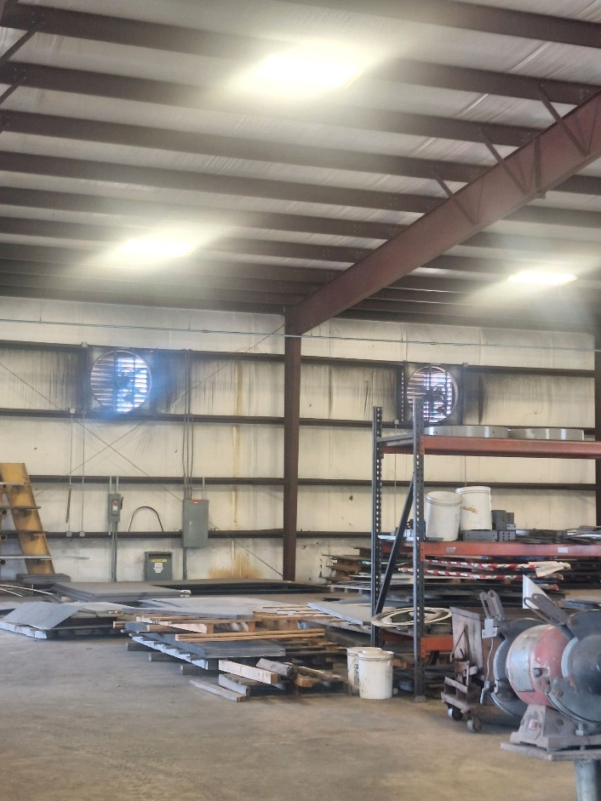

Recommendation
LSU-ITAC recommends installing occupancy sensors in the designated locations to control the lighting. These sensors should dim the lights or turn them off when the space is unoccupied. Additionally, some areas receive ample daylight, and the lights in those areas can be controlled using daylight sensors to maintain an acceptable level of illumination.

Calculations
The facility has fluorescent light fixtures in some areas, and the lights were kept on during production and office hours. The number and power ratings of all lighting fixtures are summarized in Table ‎4-5. Based on the information provided by the facility personnel, we conservatively estimated that each light could be turned off for about 30% of the time once the sensors are installed.

Table ‎4-5. The Summary of Existing Lighting Equipment in the Facility
Location | Type | Rated Power (W) | Number of Lights | Total Power (W)
Conference Room | F32T8 | 32 | 36 | 1,152
Office Space | F32T8 | 32 | 32 | 1,024
Kitchen | F32T8 | 32 | 16 | 512
Total Power for Occupancy Sensor (W_{o}) |  |  |  | 2,688
Warehouse | F32T8 | 32 | 288 | 9,216
Powerhouse | F32T8 | 32 | 40 | 1,280
Total Power for Daylight Sensor (W_{d}) |  |  |  | 10,496
Total Power (W) |  |  |  | 13,184

Current Energy Usage
The amount of current annual energy usage can be calculated using the following equation:
EU_{C} = W × CF × LH
= 13,184 W × 0.001 kW/W × 2,340 hrs/yr
= 30,851 kWh/yr,
where
EU_{C} = Current Annual Energy Usage, kWh/yr
W = Total Wattage of Lights
CF = Conversion Factor (kW/W) = 0.001 kW/W
LH = Current Lighting Hours = 2,340 hrs/yr

Proposed Energy Usage
After the facility installs the occupancy sensors, the annual electricity usage can be calculated as follows:
EU_{P} = W × CF × POH
= 13,184 W × 0.001 kW/W × 1,638 hrs/yr
= 21,595 kWh/yr,

where
EU_{P} = Proposed Annual Energy Usage, kWh/yr
W = Total Wattage of Lights
CF = Conversion Factor (kW/W) = 0.001
POH = Proposed Annual Operation Hours = 2,340 hrs/yr × 0.7 = 1,638 hrs/yr

Electrical Energy Savings
The total amount of electrical energy savings for this implementation can be calculated as:
ER = EU_{C} – EU_{P}
= 30,851 kWh/yr – 21,595 kWh/yr
= 9,256 kWh/yr,

where
ER = Energy Reduction, kWh/yr
EU_{C} = Total Current Annual Energy Usage, kWh/yr
EU_{P} = Proposed Annual Energy Usage, kWh/yr

Electrical Energy Cost Savings
The total energy cost savings after the facility installs the occupancy sensors can be calculated using:
ECS = ER × UR
= 9,256 kWh/yr × $ 0.086 /kWh
= $796/yr,

where
ECS = Total Energy Cost Savings, $/yr
ER = Energy Reduction, kWh/yr
UR = Average Electrical Energy Usage Rate = $0.086/kWh

Total Cost Savings
In this case, the total cost savings are the electrical energy cost savings:
TCS = ECS
= $796/yr,

where
TCS = Total Cost Savings
ECS = Total Electrical Energy Cost Savings, $/yr

Carbon Dioxide Reduction
Due to the reduced electrical usage, there will also be lower carbon dioxide emissions at the electric power generation. These reductions can be calculated using:
CO₂ = ER × K₁ × K₂
= 9,256 kWh/yr × (0.763 lb. CO₂ / kWh) × 1 Ton/2,000lb
= 4 Tons/yr,

where
CO₂ = Amount of Carbon Dioxide Reduced, Tons CO₂/yr
ER = Electrical Energy Reduction, kWh/yr
K₁ = Amount of CO₂ Produced per kWh = 0.763 lb. CO₂/kWh
K₂ = Conversion Factor = 1 ton/2,000 lbs

Implementation Cost
Implementation will involve the cost of daylight and occupancy sensors and the cost of installation. It is estimated that the average cost of a daylight sensor is $1004F,, and an occupancy sensor,, is $55 (see Figure 4-2). It is assumed that the labor cost is $25/hr, and the time needed for installation is one hour per sensor. It is estimated that the facility will need 6 occupancy sensors for the conference room, office, office space, and kitchen, and 6 daylight sensors for the warehouse and powerhouse.

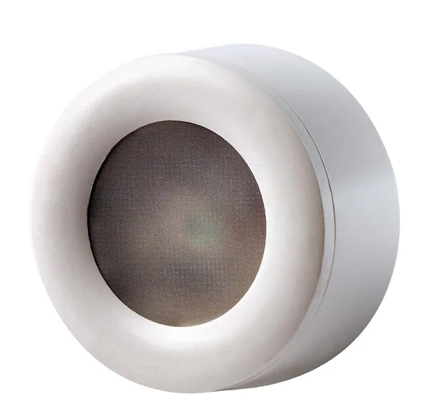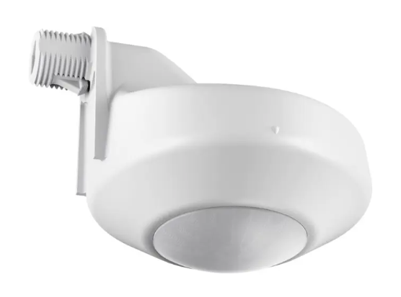

Figure ‎4-4. Daylight Sensor and Occupancy Sensor

Also, Entergy has a rebate program available for occupancy and daylight sensor installation. According to the prescriptive incentive rates requirement, the facility qualifies as a large commercial entity since its monthly peak demand exceeds 100 kW. The incentive rate is $0.11/W of light covered by sensors. Entergy only gives incentives on whichever is lower among material cost and electrical energy cost savings. The total implementation cost can be estimated by:
IC = (OC × ON – IO × W_{o}) + (DC × DN – ID × W_{d}) + LR × LT
= ($55 × 6 – $0.11/W × 2,688W) + ($100 × 6 – $0.11/W × 10,496W) + $25/hour × 12 hours
= $0 (material) + $300 (labor)
= $300
where
IC = Implementation Cost, $
OC = Cost per Occupancy Sensor= $55
ON = Number of Occupancy Sensors Needed
IO = Incentive Rate for Occupancy Sensor Installation, $0.11/W
W_{o} = Collective Wattage for Occupancy Sensor Installment, W
DC = Cost per Daylight Sensor= $100
DN = Number of Daylight Sensors Needed
ID = Incentive Rate for Daylight Sensor Installation, $0.11/W
W_{d} = Collective Wattage for Daylight Sensor Installment, W
LR = Labor Rate, $/hour
LT = Labor Time per Sensor Installation, hour

Since the incentive cannot be higher than the material cost, the material cost would be zero as the incentive will cover it. The implementation cost of this recommendation is summed up
Table ‎4-6.
Table ‎4-6. The Implementation Cost Summary for AR No. 2
Item | Quantity | Unit Cost | Incentives | Cost ($)
Material (Occupancy Sensor) | 6 | $55/unit | $0.11/W | 0
Material (Daylight Sensor) | 6 | $100/unit | $0.11/W | 0
Labor | 12 | $25/hr | - | 300
Total Implementation Cost |  |  |  | 300

Payback Period
PP = IC / TCS
= $300 / ($796/yr)
= 0.38 yrs,
where
PP = Payback Period, yrs
IC = Implementation Cost, $
TCS = Total Cost Savings, $/yr

AR No. 3 – HVAC Tune-Up to Increase Energy Efficiency
(ARC Code 2.7211)
Table ‎4-7. The Savings Summary for AR No. 3
Energy Savings (kWh/yr) | Energy Cost Savings ($/yr) | Total Cost Savings ($/yr) | CO₂ Reduction (Tons/yr) | Imp. Cost ($) | Payback Period  (yr)
8,676 | 746 | 746 | 3 | 392 | 0.53

Observation and Analysis
During the assessment tour, the LSU-ITAC team found that the facility has four HVAC units. The facility management mentioned not having a regular HVAC maintenance program for the units at the facility. This could lead to reduced efficiency and higher energy consumption from the HVAC units (see Figure ‎4-5). A tune-up and maintenance schedule helps to ensure proper cooling of the conditioned space and meet the desired temperature requirement. We obtained the energy efficiency rating (EER) from the nameplates of the units, which conforms with ASHRAE Building Efficiency Standards. The summary of the old HVAC units is shown in Table ‎4-8.

Table ‎4-8. The Summary of Old HVAC Units in the Center
HVAC Unit Tonnage | Quantity | Total Tonnage | EER
6 ton | 4 | 24 ton | 11.5

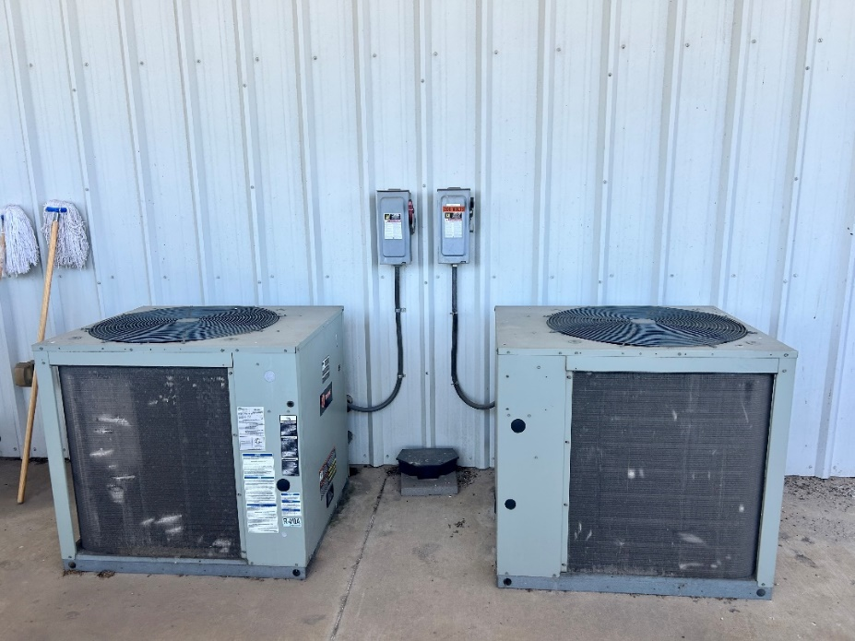
Figure ‎4-5. Some of the HVAC Units

Recommendation
LSU-ITAC recommends performing an HVAC tune-up which involves checking, adjusting, and resetting the equipment to factory conditions such that it operates closer to the performance level of a new unit. A typical HVAC-tune-up checklist may include inspecting and cleaning the condenser, evaporator, and blower, inspecting the refrigerant level, calibrating the thermostat, tightening all electrical connections, changing air filters, etc. This recommendation will increase efficiency and improve comfort, reducing energy consumption and costs.

Calculations
The electrical savings calculation is estimated from the energy efficiency ratio (EERpre) before performing the AC tune-up. The EERpre can be determined by the efficiency loss percentage (EL) calculated from the refrigerant charge level. Due to the time limitation during the assessment, the team was not able to calculate the efficiency loss, but the incorrect refrigerant level has been proven to reduce efficiency by close to 20%, leaking ducts reduce efficiency by 20%, and unclean blower component can reduce efficiency by 15% which limits the system airflow. Hence, we conservatively estimate that the efficiency reduction due to improper maintenance is 15% for the calculations. Recalling that the current cooling hours at the building type is 1,997 hrs/yr as estimated for Louisiana by the New Orleans Energy Smart Technical Reference Manual. Thus, we estimate the EERpre and electrical energy savings using the formula referenced in the technical manual.

Calculate the Current Efficiency of HVAC Units
EERpre = (1 − EL) × EERpost
= (1 – 0.15) × 11.5 Btu/hr/Watts
= 9.8 Btu/hr/Watts,
where
EERpre = Current Average Energy Efficiency Ratio.
EL = Efficiency Loss
EERpost = Average Energy Efficiency Derived from Manufacturer's label.

Electrical Energy Savings
The electrical energy savings are calculated using the formula below:
ER = RC × B × ECH × (1/ EER_{pre} – 1/ EER_{post}) × CF
= 24 ton × 12,000 Btu/hr/ton × 1,997 hrs/yr × (1/9.8 – 1/11.5) W/Btu/hr × 0.001kW/W
= 8,676 kWh/yr,
where
ER = Energy Reduction, kWh/yr
RC = Total Rated Capacity of the HVAC units, tons
B = Conversion Constant, Btu/hr/ton
ECH = Equivalent Full-Load Cooling Hours, hrs/yr
EERpre = Current Average Energy Efficiency Ratio.
EERpost = Average Energy Efficiency Derived from Manufacturer's label.
CF = Conversion Factor, kW/W

Electrical Energy Cost Savings
The total energy cost can be calculated using:
ECS = ER × UR
= 8,676 kWh/yr × $0.086/kWh
= $746/yr,

where
ECS = Total Energy Cost Savings, $/yr
ER = Energy Reduction, kWh/yr
UR = Average Electrical Energy Usage Rate = $0.086/kWh

Total Cost Savings
In this case, the total cost savings are the electrical energy cost savings:
TCS = ECS
= $746/yr,

where
TCS = Total Cost Savings, $/yr
ECS = Total Electrical Energy Cost Savings, $/yr

Carbon Dioxide Reduction
Due to the reduced electrical usage, there will also be lower carbon dioxide emissions from the electric power generation. These reductions can be calculated using:
CO₂ = ER × K₁ × K₂
= 8,676 kWh/yr × (0.763 lb. CO₂ / kWh) × 1 Ton/2,000lb
= 3 Tons/yr,

where
CO₂ = Amount of Carbon Dioxide Reduced, Tons CO₂/yr
ER = Electrical Energy Reduction, kWh/yr
K₁ = Amount of CO₂ Produced per kWh = 0.763 lb. CO₂/kWh
K₂ = Conversion Factor = 1 ton/2,000 lbs

Implementation Cost
Implementation will involve the labor cost to tune up all the HVAC units. It is estimated that it takes two hours of labor for each HVAC unit's tune-up, and the hourly cost is about $100/hr. For a total of 4 HVAC units, the estimated labor cost will be $800. However, Entergy Solution provides a customized incentive for AC tune-up, which is $17/ton. The implementation cost is shown in Table ‎4-9.
Table ‎4-9. The Implementation Cost Summary for AR No. 3
Cost Types | Quantity | Unit Cost | Cost ($)
AC-Tune Up | 4 units | $200/unit | 800
Incentive | 24 | $17/ton | -408
Total Implementation Cost |  |  | 392

Payback Period
PP = IC / TCS
= $392 / ($746/yr)
= 0.53 yrs,

where
PP = Payback Period, yrs
IC = Implementation Cost, $
TCS = Total Cost Savings, $/yr

  - AR No. 4 – Utilize Higher Efficiency Lamps and/or Ballasts
(ARC Code 2.7142)

Table ‎4-10. The Savings Summary for AR No. 4
Energy Savings (kWh/yr) | Energy Cost Savings  ($/yr) | Demand Savings  (kW/yr) | Demand Cost  Savings  ($/yr) | Total Cost Savings ($/yr) | CO₂  Reduction (tons/yr) | Imp. Cost ($) | Payback Period  (yrs)
13,498 | 1,161 | 69 | 1,207 | 2,368 | 5 | 2,575 | 1.09

Observation and Analysis
During the assessment tour, the LSU ITAC team noticed that fluorescent lighting fixtures were used in multiple areas in the facility. These lights operate regularly throughout the standard shift hours. The team recognized that replacing the existing fluorescent fixtures with energy-efficient LEDs could offer significant potential for energy savings and reduced operating costs. In total, the number and power ratings of all fluorescent lighting fixtures are summarized in Table ‎4-11.
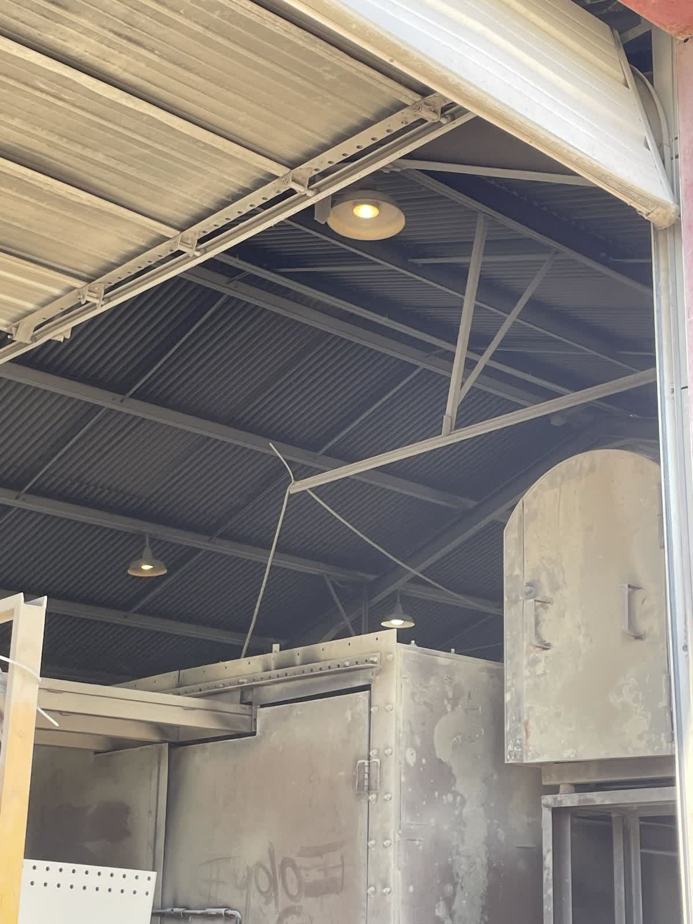

Figure ‎4-7. Fluorescent Light in the Facility.

Table ‎4-11. The Summary of Existing Lighting Equipment in the Facility
Location | Type | Rated Power (W) | Number of Lights | Total Power (W)
Conference Room | F32T8 | 32 | 36 | 1,152
Warehouse | F32T8 | 32 | 288 | 9,216
Powerhouse | F32T8 | 32 | 40 | 1,280
Office Space | F32T8 | 32 | 32 | 1,024
Kitchen | F32T8 | 32 | 16 | 512
Total Power (W) |  |  |  | 13,184

Recommendation
For the maximum cost and environmental benefits, our team recommends upgrading all the facility’s lighting equipment with LED lights. The advantages of LED lights are that they can work without a ballast, have much lower-rated power, and maintain their initial lumen outputs while lasting longer than fluorescent lights. Additionally, the LED lights produce much less heat when in operation. The facility can gradually phase out the current lighting equipment every time a piece burns out and mount the new LED ones. The facility can switch out the current fluorescent lighting fixtures with the replacement of LED fixtures that is rated, as shown in Table ‎4-12.

Table ‎4-12. The Summary of Recommended Lighting Equipment in the Facility
Type | Rated Power/ea. (W) | Quantity | Total Power (W)
4ft T5 LED | 18 | 412 | 7,416

Calculations
Current Energy Usage
The current fluorescent lights run for the ordinary shift hours. Therefore, current energy consumption for lighting can be estimated as follows:
EU_{C} = W_{F32} × OH × CF
= 13,184 W × 2,340 hrs/yr × 0.001 kW/W
= 30,851 kWh/yr,
where
EU_{C} = Current Annual Energy Usage, kWh/yr
W_{F32} = Collective Wattage of 4ft F32T8 Tubes
OH = Operation Hours for Lights = 45 hours/week × 52 weeks/year = 2,340 hrs/yr
CF = Conversion Factor (kW/W) = 0.001

Proposed Energy Usage
After the facility upgrades all fixtures to LED, the annual electricity usage can be calculated as follows:
EU_{P} = W_{4ftT5} × OH× CF
= 7,416W × 2,340 hrs/yr × 0.001 kW/W
= 17,353 kWh/yr,

where
EU_{P} = Proposed Annual Energy Usage, kWh/yr
W_{4ftT8} = Collective Wattage of 4ft T8 LED Tubes
OH = Operation Hours for Lights = 45 hours/week × 52 weeks/year = 2,340 hrs/yr
CF = Conversion Factor (kW/W) = 0.001

Electrical Energy Savings
The total amount of electrical energy savings for this implementation can be calculated:
ER = EU_{C} – EU_{P}
= 30,851 kWh/yr – 17,353 kWh/yr
= 13,498 kWh/yr,

where
ER = Electrical Energy Reduction, kWh/yr
EU_{C} = Current Electrical Energy Usage, kWh/yr
EU_{P} = Proposed Electrical Energy Usage, kWh/yr

Electrical Energy Cost Savings
The total electrical energy cost savings with the replacement of all the current lights with LED lights in the facility can be estimated by the following equation:
ECS = ER × UR
= 13,498 kWh/yr × $0.086 /kWh
= $1,161/yr,

where
ECS = Total Electrical Energy Cost Savings, $/yr
ER = Electrical Energy Reduced, kWh/yr
UR = Average Electrical Energy Usage Rate = $0.086/kWh

Electrical Demand Savings
The total amount of electrical demand savings can be calculated using the following equation:
EDS = (W_{F32} –W_{T8L}) × CF × 12 months
= (13,184 W – 7,416 W) × 0.001 × 12 months
= 69 kW/yr,
where
EDS = Estimated Demand Savings, kW/yr
W_{T8} = Collective Wattage of 4ft F32T8 Fluorescent Tubes
W_{T8L} = Collective Wattage of 4ft T8 LED Tubes
CF = Conversion Factor (kW/W) = 0.001
Electrical Demand Cost Savings
By lowering the amount of energy, the facility uses during its peak demand period, there will be a lower demand charge. The amount of energy demand cost savings (EDCS) can be estimated using the following equation:
EDCS = EDS × DR
= 69 kW/yr × $17.49/kW
= $1,207/yr,

where
EDCS = Estimated Demand Cost Savings, $/yr
EDS = Electrical Demand Savings, kW/yr
DR = Demand Charge = $17.49/kW

Total Cost Savings
Since there has been a demand charge on the facility, the total cost savings is the sum of electrical energy cost savings and estimated demand cost savings:
TCS = ECS + EDCS
= $1,161/yr + $1,207/yr
= $2,368/yr,

where
TCS = Total Cost Savings, $/yr
ECS = Total Electrical Energy Cost Savings, $/yr
EDCS = Estimated Demand Cost Savings, $/yr

Carbon Dioxide Reduction
Due to the reduced electrical usage, there will also be lower carbon dioxide emissions from the electrical power generation. These reductions can be calculated using:
CO₂ = ER × K₁ × K₂
= 31,291 kWh/yr × (0.763 lb CO₂ / kWh) × 1 Ton/2,000lbs
= 5 Tons/yr,

where
CO₂ = Amount of Carbon Dioxide Reduced, Tons/yr
ER = Electrical Energy Reduction, kWh/yr
K₁ = Amount of CO₂ Produced per kWh, 0.763 lb CO₂/kWh
K₂ = Conversion Factor = 1 Ton/2,000 lbs

Implementation Cost
Implementation will involve the labor cost required to replace the lighting fixtures, along with the material cost of the LED lighting equipment. It is assumed that the labor cost is $25/hour, with the time needed for the replacement to be 0.2 hours per fixture for LED tubes. The LED lighting costs, $9/tubes for 4ft F32 replacement.

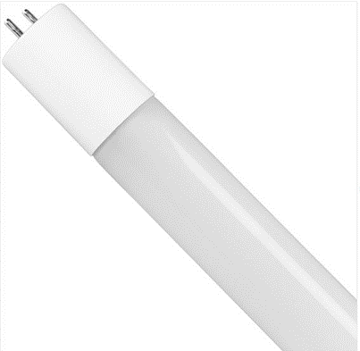
Figure ‎4-6. Recommended LED Lighting Types

Also, Entergy has a rebate program available in LED lighting fixture retrofit. According to the prescriptive incentive rates requirement, the facility qualifies as a large commercial entity since its monthly peak demand are more than 100 kW. The incentive rate is $4 for every 32W 4ft T8 light replacement. The total implementation cost can be estimated by:
IC = N_{4ftT5} × (UC_{4ftT5} – I_{4ftT5}) + LR × LT × F_{4ftT5}
= 412 × ($9/tube – $4/tube) + $25/hr × 0.2 hrs/fixture× 103 fixtures
= $2,060 (material) + $515 (labor)
= $2,575,

where
IC = Implementation Cost, $
N_{4ftT8} = Number of 4ft T8 LED Tubes Needed
UC_{4ftT8} = Cost per 4ft T8 LED Tube, $/tube
I_{4ftT8} = Incentive Rate for Replacing 4ft T8 Tube, $/tube
LR = Labor Rate, $/hr
LT = Labor Time per 4ftT8 Fixture Replacement, hr/fixture
F_{4ftT8} = Total Number of 4ft T8 Fixtures

Since the incentive cannot be greater than $25,000, the facility can get the maximum value of $25,000 as an incentive. The implementation cost is summarized in Table ‎4-13.

Table ‎4-13. The Implementation Cost Summary for AR No. 4
Item | Quantity | Unit Cost | Cost ($)
4ft T5 LED Tube,, | 412 | $9/tube | 3,708
Incentives | 412 | $4/tube | -1,648
Total Material Cost | - | - | 2,060
Labor | (0.2 hrs/fixture for 103 fixtures 4ft T8 LED) = 20.6 hrs. | $25/hr | 515
Total Implementation Cost |  |  | 2,575

Payback Period
PP = IC / TCS
= $2,575/ ($2,368/yr)
= 1.09 yrs,

where
PP = Payback Period, yrs
IC = Implementation Cost, $
TCS = Total Cost Savings, $/yr

  - AR No. 5 – Clean or Color Roof to Reduce Solar Load
(ARC Code 2.7425)

Table ‎4-14. The Savings Summary for AR No. 5
Energy Savings (kWh/yr) | Energy Cost Savings ($/yr) | Total Cost Savings ($/yr) | CO₂ Reduction (Tons/yr) | Imp. Cost ($) | Payback Period  (yr)
36,337 | 3,125 | 3,125 | 14 | 12,153 | 3.89

Observation and Analysis
The LSU-ITAC team observed that the facility's roof was not coated with reflective paint or any cool roof mechanism during the assessment. Our team noticed that the color of the existing rooftop is dark, which absorbs a lot more heat than a light coat because it absorbs more radiation energy. Conventional roofs can reach temperatures of 150°F or more on a sunny summer afternoon. Under the same conditions, a reflective roof could stay more than 50°F (28 °C) cooler. Furthermore, the ability of the reflective coatings to reduce the effect of radiation energy will consequently decrease the cooling load on the HVAC in space; as a result, energy savings can be achieved.

Recommendation
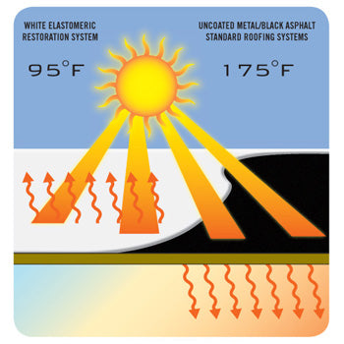
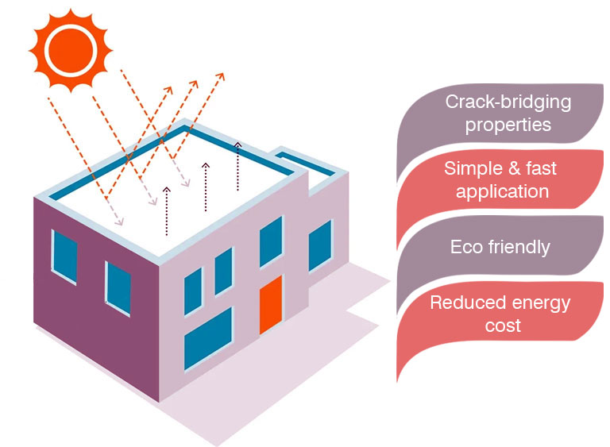
Based on our observations and according to the facility's personnel, it takes longer to achieve a cool and comfortable indoor temperature during the summer. We recommend applying cool roof coating19F, also known as cool roof paint, to better reflect the sun, keeping the building cooler on the inside and helping improve indoor thermal comfort and decrease the cooling load of the HVAC system. Figure ‎4-9 shows the concept of the cool roof coating20F,21F.

Figure ‎4-7. The Concept of the Cool Roof Coating
Calculations
Current Electrical Energy Usage
Implementing a cool roof will improve the thermal comfort of the working space by reducing the cooling load on the HVAC system. We assume that the indoor temperature equals the outdoor temperature over a year. The Oak Ridge National Laboratory's comprehensive roofing savings calculator22F estimates the potential energy savings from installing a reflective coat based on the Solar Reflectance Index (SRI), Infrared Emissivity (IE), and R-value of the proposed cool roof. The calculator factors in the location, utility, and demand rate of the facility, the coefficient of performance of the HVAC, and the heating system. The input data for the calculator is shown in Figure ‎4-10. The output of the calculator provides essential data such as the total energy savings, and average heat reduction during the cooling season. The output of the calculator is represented in Figure ‎4-11.

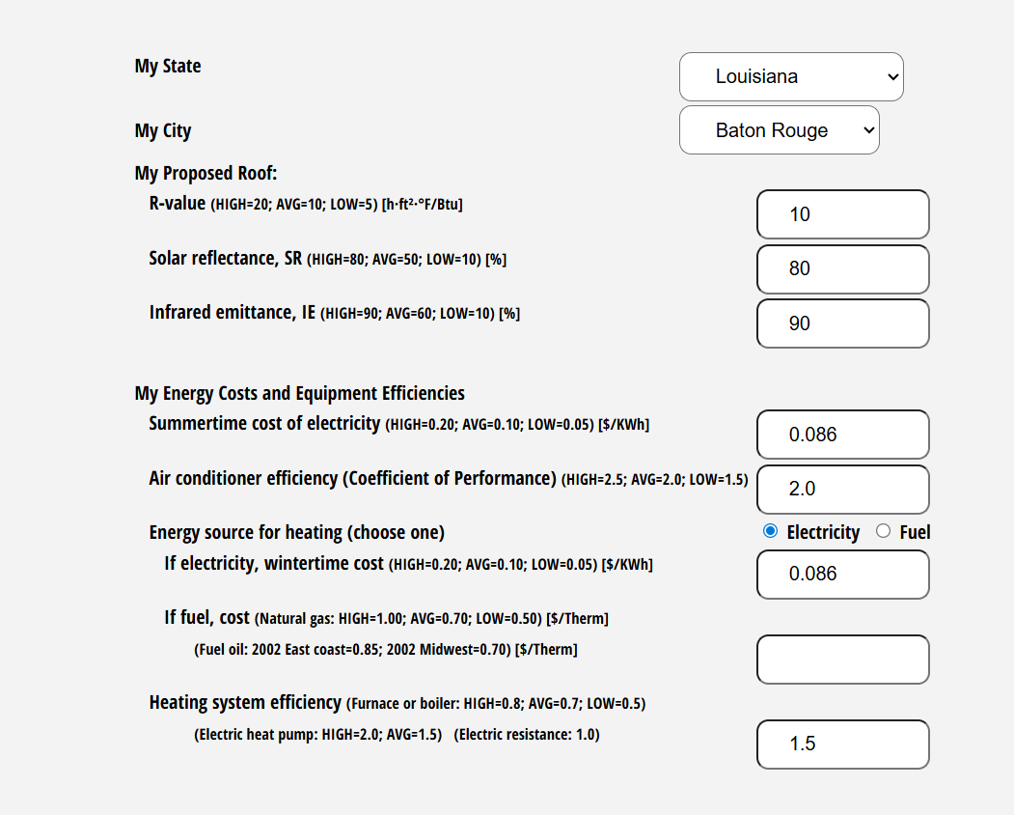
Figure ‎4-8. Input Data to Estimate Cool Roof Potential Energy Savings.
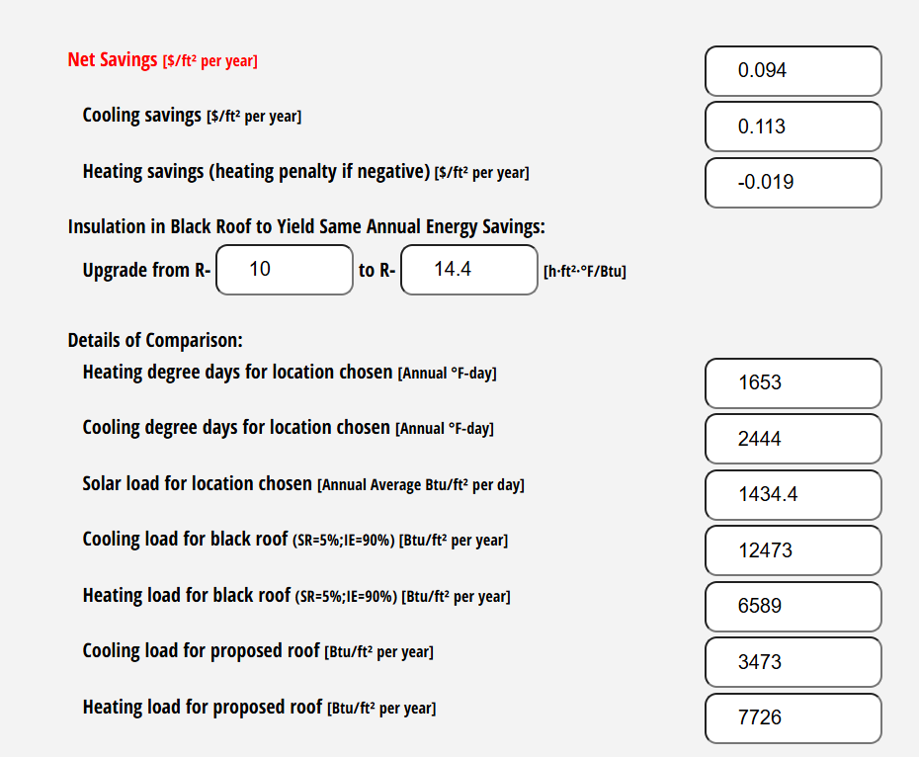
Figure ‎4-9. Output from Cool Roof Energy Saving Calculator.

Electrical Energy Cost Savings
ES = $0.09/ft²/yr, given from the calculator

TCS = ES × AF
= $(0.09)/ft²/yr × 34,725 ft²
= $3,125/yr,

where
ES = Annual Energy Savings, $/ft²/yr
AF = Area of Roof to be Coated, ft²
TCS = Total Cost Savings, $/yr

Electricity Energy Savings
The anticipated annual electricity savings are as follows:
ES = TCS / UR
= $3,125/yr / $0.086/kWh
= 36,337 kWh/yr,

where
ES = Electrical Energy Savings, kWh/yr
UR = Utility Rate, $0.86/kWh
TCS = Total Cost Savings, $/yr

Carbon Dioxide Reduction
Because of the resulting lower electrical usage, the plant will be responsible for lower emissions of carbon dioxide at the point of electric power generation. These reductions are calculated as follows:
CO₂ = ES × K₁ × K₂
= 36,337 kWh/yr × 0.763 lb. CO₂ / kWh × 1 Ton/2,000 lb
= 14 Tons CO₂/yr,

where
ES = Electrical Energy Savings, kWh/yr
K₁ = Conversion Factor, 0.763 lb. CO₂ / kWh
K₂ = Conversion Factor, 1 Ton/2,000 lb.

Implementation Cost
Implementation will involve the cost of a white latex coating with the highest solar reflectance and emissivity23F,24F (see Figure ‎4-12) and Installation cost. The reflective coat coverage depends on the product type and manufacturer's specifications. Most of the advertised coverage of the coating paint is around 100 ft²/gallon25F. The price of a gallon of white acrylic coating selected for this calculation is $134/bucket ($28/gallon). We estimate 25% of the material cost as the installation cost.
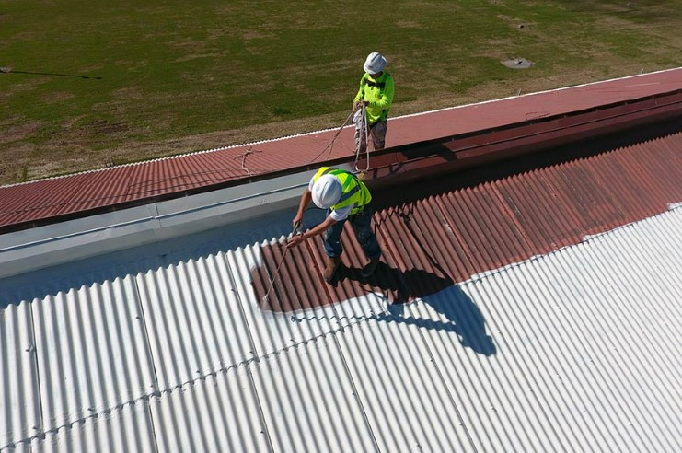
Figure ‎4-10. Acrylic Roof Coating with the highest reflectance and UV resistant26F

Implementation Cost
The total implementation cost can be estimated as follows,
IC = Material Cost + Labor Cost
= ((AF/Cp) × P_{CF})) + LR
= ((34,725 ft²/100 ft²/gallon) × $28/gallon)) + LR
= $9,723 + (25% × $9,723)
= $12,153,

where
IC = Implementation Cost, $
AF = Area of Roof to be Coated, ft²
Cp = Estimated Coverage Area of Reflective Paint, ft²/gallon
P_{CF} = Cost Price of Reflective Paint, $21/Gallon
LR = Labor Rate, $/hr

Table ‎4-15. The Implementation Cost Summary for AR No. 5
Item | Quantity | Unit Cost | Cost ($)
Acrylic Roof Coating27F | 34,725 ft²/100 ft²/gallon = 347.25 Gallons | $28/Gallon | 9,723
Labor | 25% of the material cost | - | 2430
Total Implementation Cost |  |  | $12,153

Payback Period
PP = IC / TCS
= $12,153 / ($3,125/yr)
= 3.89 yrs,
where
PP = Payback Period, yrs
IC = Implementation Cost, $
TCS = Total Cost Savings, $/yr

AR No. 6 – Replace Existing CNC Press Machines with More Suitable Substitutes
(ARC Code 4.652)

Table ‎4-16. The Savings Summary for AR No. 6
Energy Savings (kWh/yr) | Energy Cost Savings ($/yr) | Operational Cost Savings ($/yr) | Total Cost Savings ($/yr) | CO₂ Reduction (Tons/yr) | Imp. Cost ($) | Payback Period  (yr)
28,080 | 2,414 | 68,060 | 70,474 | 10 | 710,000 | 10.07

Observation and Analysis
During the assessment tour, the LSU-IAC team found that the facility operates with one older CNC Press machine that is very old, specification is shown in Figure ‎4-11. Upgrading these machines to a newer, smart machine could notably reduce labor and offer maintenance and energy efficiency improvements. This change promises considerable savings and increased productivity.

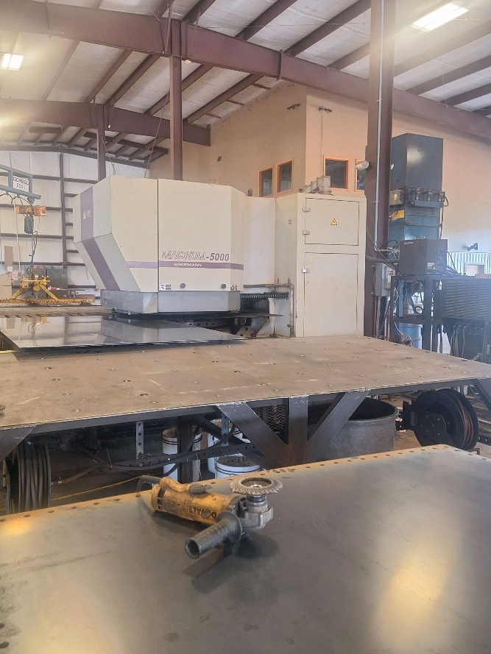
Figure ‎4-11. The CNC turning machine at the warehouse

Recommendation
According to the facility personnel, the CNC Press machines are old and need to be replaced. Therefore, LSU-IAC recommends that the facility replace its old CNC Pressing machines with a new, more efficient machine. This modern machine is valued at $710,000. It would also likely offer improved energy efficiency, lower maintenance costs due to its newer technology, and potentially higher production output with better quality control. The initial investment in this machine could be offset by these long-term savings. Furthermore, consolidating the process into a more advanced machine can offer the facility additional flexibility for future operational needs or expansions. This recommendation aims to enhance the efficiency and productivity of the facility's packaging department, aligning with modern manufacturing practices and potentially providing a quick return on investment. This recommendation will result in reduced energy and maintenance costs.
Calculations
Current Energy Usage
The amount of current annual energy usage can be calculated using the following equation
EU_{C} = RC_{c} × OH × LF_{C} × N
= 35 kW× 2,340 hrs/yr × 0.8 × 1
= 65,520 kWh/yr,

where
EU_{C} = Current Annual Energy Usage, kWh/yr
RCc = Rated Capacity of the Current CNC Pressing Machine units = 35 kW
OH = Operation Hours for CNC Pressing Machine
= 2,340 hrs/yr
LF_{C} = Estimated Load Factor for CNC Machine, 0.8
N = Number of Machines

Proposed Energy Usage
After the facility installs the higher efficiency CNC turning Machine units, the annual electricity usage can be calculated as follows:
EU_{C} = RC × K × OH × LF_{C} × N
= 20 kW× 2,340 hrs/yr × 0.8 ×1
= 37,440 kWh/yr,

where
EU_{P} = Proposed Annual Energy Usage, kWh/yr
RC_{P} = Rated Capacity of proposed CNC Pressing Machine = 20 kW
OH = Operation Hours for CNC Pressing Machine
= 2,340 hrs/yr
LF_{C} = Estimated Load Factor for CNC Pressing Machine, estimated at 0.8
N = Number of Machines

Electrical Energy Savings
The total amount of electrical energy savings for this implementation can be calculated as:
ER = EU_{C} – EU_{P}
= 65,520 kWh/yr – 37,440 kWh/yr
= 28,080 kWh/yr,

where
ER = Energy Reduction, kWh/yr
EU_{C} = Total Current Annual Energy Usage, kWh/yr
EU_{P} = Proposed Annual Energy Usage, kWh/yr

Electrical Energy Cost Savings
The total energy cost can be calculated using:
ECS = ER × UR
= 28,080 kWh/yr × $0.086/kWh
= $2,414/yr,
where
ECS = Total Energy Cost Savings, $/yr
ER = Energy Reduction, kWh/yr
UR = Average Electrical Energy Usage Rate = $0.086/kWh

Operational Costs
The current annual operational costs are calculated considering labor, energy usage, and maintenance costs for the one older crusher and screener:
LC_{C} = NO × OH₁ × WH × N
= 2×6 hrs/day ×260 × $24/hr × 1
= $74,880/yr,
MC_{C} = AM_{C} × N
= 12,000 × 1
= $12,000 /yr,

where
LC_{C} = Labor Cost for Current Operations, $/yr
OH₁ = Operation Hours for CNC Pressing
= 5 Days/Week × 52 Weeks/Year = 260 days/yr
WH = Wage per Hour for operators, $25/hr
NO = Number of Operators required for old machines = 2 operators
MC_{C} = Maintenance Cost for Current Operations, $/yr
AMC = Annual Maintenance cost = $8,000
N = Number of Machines

Proposed Operational Costs
With the new system, operational costs are recalculated, considering reduced labor and no maintenance costs during the warranty, which is believed to fall within the payback period:
LC_{P} = NO × OH₁ × WH × N
= 1 × 3 hrs/day ×260 days × $24/hr × 1
= $18,720/yr,

MC_{P} = $0/yr (due to longer warranty for newer machines),

where
LC_{C} = Labor Cost for Current Operations, $/yr
OH₁ = Operation Hours for CNC Pressing Machine
= 5 Days/Week × 52 Weeks/Year = 260 days/yr
WH = Wage per Hour for operators, $26/hr
NO = Number of Operators required for New Machine = 1 operator
MC_{P} = Maintenance Cost of CNC Pressing Machine = 0

Total Cost Savings
In this case, the total cost savings are the electrical energy cost savings and operational cost savings:
TCS = ECS + OCS
= $2,414/yr + $74,780/yr + $12,000/yr - $18,720/yr
= $70,474/yr,

where
TCS = Total Cost Savings, $/yr
ECS = Electrical Energy Cost Savings, $/yr
OCS = Operational Cost Savings per year (including labor and maintenance savings)

Carbon Dioxide Reduction
Due to reduced electrical usage, there will also be lower carbon dioxide emissions from electric power generation. These reductions can be calculated using:
CO₂ = ER × K₁ × K₂
= 28,080 kWh/yr × (0.763 lb. CO₂ / kWh) × 1 Ton/2,000lb
= 10 Tons/yr,

where
CO₂ = Amount of Carbon Dioxide Reduced, Tons CO₂/yr
ER = Electrical Energy Reduction, kWh/yr
K₁ = Amount of CO₂ Produced per kWh = 0.763 lb. CO₂/kWh
K₂ = Conversion Factor = 1 ton/2,000 lbs

Implementation Cost
The estimated implementation cost for the new CNC Press Machine, including purchase, installation, integration, and controls upgrade, as informed by the facility personnel, will have a total cost of $710,000. This amount is the comprehensive cost, including both the purchase price of the machine and all associated installation and labor costs. Therefore, the facility will incur no additional expenses beyond the $710,000 for the complete setup and operational readiness of the ammonia compressor Unit.

Payback Period
PP = IC/TCS
= $710,000/ ($70,474/yr)
= 10.07 yrs,

where
PP = Payback Period, yrs
IC = Implementation Cost, $
TCS = Total Cost Savings, $/yr

AR No. 7 – Use Solar Heat to Generate Electricity
(ARC Code 2.9114)

Table ‎4-17. The Savings Summary for AR No. 7
Energy Savings (kWh/yr) | Energy Cost Savings ($/yr) | Total Cost Savings ($/yr) | CO₂ Reduction (tons/yr) | Imp. Cost ($) | Payback Period (yrs)
437,832 | 37,653 | 37,653 | 167 | 526,500 | 13.98

Observation and Analysis
During the assessment, the LSU-ITAC team was informed that the facility is interested in installing solar panels to generate electricity on-site. The facility currently has a parking area and almost no shade from the surroundings, as shown in Figure ‎4-12. Also, the facility currently uses around 439,218 kWh/yr of electricity at a total cost of $78,675/yr. Installing solar panels and using electricity generated therein would cut its electricity bills, in addition to the environmental benefits.


Figure ‎4-12. Facility Space

Recommendation
We used the NREL solar calculator to predetermine the potential capacity of the solar system that can be fitted into the empty space as shown in Figure ‎4-13. The largest space area has the potential for a maximum of 300 kW. According to the electricity provider's website, a Net Metering program is available for its customers for up to 300 kW of power generation, allowing customers to receive a credit on their bill for any extra electricity produced. Hence, the facility is interested in installing a solar panel system with a capacity of 300 kW to generate electricity from solar heat.

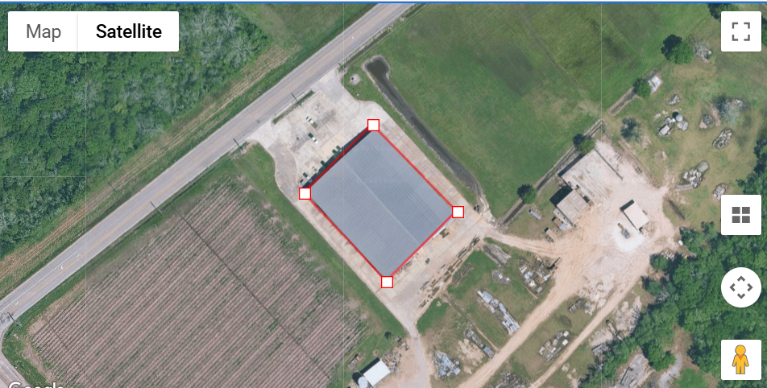
Figure ‎4-13. Theoretical Maximum System Capacity

Calculations
The electrical energy generated by a 300-kW photovoltaic (PV) array was simulated using the NREL solar calculator. The NREL solar calculator determines annual electrical energy output from a PV system by calculating solar radiation using the local meteorological data, factoring in the system specifics, and finally summing electrical output over all 8,760 hours in a year. The system specifics and results are shown in Figure ‎4-14. respectively.

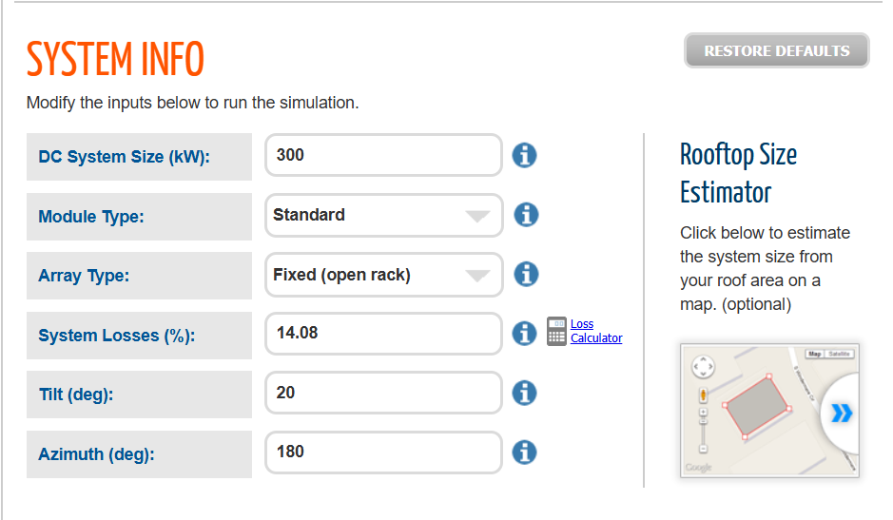
Figure ‎4-14. The System Specifics Inputs

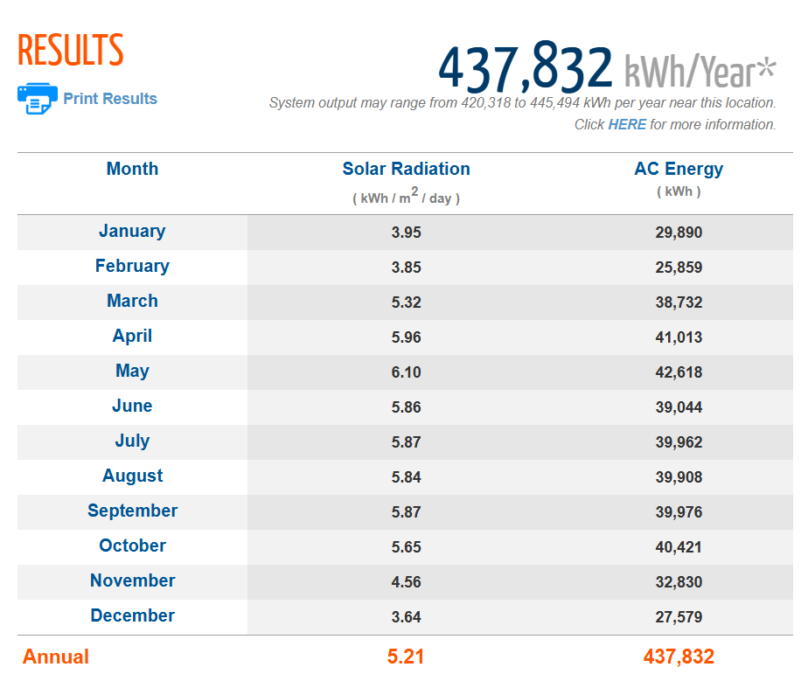
Figure ‎4-15. The Yearly Solar Savings Results

Electricity Energy Savings
As shown in Figure ‎4-15, the anticipated annual electricity savings are as follows:
ES = 437,832 kWh/yr,

where
ES = Electricity Energy Reduction, kWh

Electrical Energy Cost Savings
Using the average electrical energy usage rate for the facility, we can calculate the electrical energy cost savings as follows:
ECS = ES × UR
= 437,832 kWh/yr × $0.086/kWh
= $37,653/yr,

where
ECS = Electrical Energy Cost Savings, $/yr
ES = Energy Savings, kWh/yr
UR = Average Electrical Energy Usage for the Facility = $0.086 kWh

Total Cost Savings
Since the facility does not report the demand charge, we do not have a reference for such usage. Therefore, we cannot determine how much demand can be saved by using solar panels. Hence, the total cost savings is estimated as the electrical energy cost savings:
TCS = ECS
= $37,653/yr,

where
TCS = Total Cost Savings, $/yr
ECS = Electrical Energy Cost Savings, $/yr

Carbon Dioxide Reduction
Because of the resulting lower electrical usage, the plant will be responsible for lower emissions of carbon dioxide at the point of electric power generation. These reductions are calculated as follows:
CO₂ = ES × K₁ × K₂
= 437,832 kWh/yr × 0.763 lb. CO₂ / kWh × 1 Ton/2,000 lb
= 167 Tons CO₂/yr,

where
ES = Electrical Energy Savings, kWh/yr
K₁ = Conversion Factor, 0763 lb. CO₂ / kWh
K₂ = Conversion Factor, 1 Ton/2,000 lb.

Implementation Cost
The installation cost of a solar system is based on the cost per watt. In Louisiana, the installation cost for thin film solar panels is around $2.25/W based on several online quotes we received from the installers and some online resources, Louisiana does not provide any incentives for solar panel installation for commercial operations like some neighboring states, but a 26 percent Federal Solar Investment Tax Credit (ITC) can be claimed for systems installed in 2020-2022. The ITC then steps down to 22 percent for projects that begin in 2023, and starting in 2024, the tax credit will expire. It is better to apply for this credit program sooner. For our calculation purposes, we are considering the federal tax incentive as 22% by assuming that the facility will consider the project for the year 2023. The initial cost of the system, including the ITC incentive, is given in Table ‎4-18.

Table ‎4-18. The Implementation Cost Summary for AR No. 7
Item | Quantity | Unit Cost | Cost ($)
Solar Panel Installation | 300 kW | $2.25/W | 675,000
Federal Solar Investment Tax Credit | 22% of Total Installation Cost | - | 148,500
Total Implementation Cost |  |  | 526,500

Simple Payback Period
PP = IC / ECS
= $526,500 / ($37,653/yr)
= 13.98 yrs,

where
PP = Payback Period, years
IC = Implementation Cost, $
ECS = Annual Electrical Cost Savings, $/yr

THE INDUSTRIAL CONTROL SYSTEMS CYBERSECURITY ASSESSMENT
The Industrial Control Systems (ICSs) Cybersecurity Assessment Tool developed by the U.S. Department of Energy can be used to identify cybersecurity risks in small- and medium-sized manufacturing facilities. This assessment tool is based on a questionnaire to be answered by the facility's IT personnel during the assessment, as shown in Table ‎5-1. This tool can be used to identify risk areas, provide cybersecurity awareness information, and potential solutions, and suggest action items based on the response selected. Due to privacy, this client declined to answer the assessment questions, but we added this tool here for the client's self-assessment later if they decide to.

Table ‎5-1. Industrial Control Systems Cybersecurity Assessment Details
People
1 | Does your plant or facility provide basic cybersecurity awareness training to all employees? | No Comments
 | No Response
2 | Are staff assigned and trained to take appropriate measures during a cybersecurity incident? | No Comments
 | No Response
3 | Do your industrial control system (ICS) vendors provide remote support? | No Comments
 | No Response
4 | What level of on-site physical security does your facility or plant enforce upon vendors? | No Comments
 | No Response
5 | Do third party vendors have proper cybersecurity training? | No Comments
 | No Response
6 | Do vendors utilize their own equipment, hardware, or software during site visits? | No Comments
 | No Response
Process
7 | Have you identified critical equipment in your plant or facility that would cause disruption to your operations if they were compromised? | No Comments
 | No response
8 | Does a plan exist to identify and isolate impacted assets, or shut down equipment as necessary in the event of a cybersecurity incident? | No Comments
 | No Response
9 | Does your plant or facility have a cybersecurity incident response procedure? | No Comments
 | No Response
10 | Does a central repository containing equipment schematics, IT infrastructure drawings, and system network layouts exist within the facility? | No Comments
 | No Response
11 | Is cybersecurity considered when purchasing supplies or equipment, and is it defined in your contractual obligations with vendors? | No Comments
 | No Response
12 | Does plant/facility equipment get regularly or automatically scanned for cybersecurity issues (e.g., malware, etc.)? | No Comments
 | No Response
13 | Is the use of external media by staff and vendors regulated within the plant/facility and scanned for cybersecurity issues? | No Comments
 | No Response
Technology
14 | Which of the following best describes the industrial controls in your plant or facility? | No Comments
 | No Response
15 | Are indicators or alerts set up on critical equipment to indicate unusual changes to operating parameters, multiple login attempts, or detect other anomalies in use? | No Comments
 | No Response
16 | Does the plant or facility have any equipment that is programmable or reconfigurable by remote staff? | No Comments
 | No Response
17 | Does your industrial control system (ICS) allow remote access? | No Comments
 | No Response
18 | Are there processes in your plant with operating parameters that are interdependent with other processes? | No Comments
 | No Response
19 | How are modifications to parameters or set-points made within your manufacturing process? | No Comments
 | No Response
20 | Do the computers that run your industrial control system (ICS) allow employees or vendors to import files from external media? | No Comments
 | No Response
Overall Risk: -

https://www.entergy.com/userfiles/content/environment/docs/EntergyClimateScenarioAnalysis.pdf
https://www.eia.gov/environment/emissions/co2_vol_mass.php
https://www.homedepot.com/p/Leviton-Photocell-Indoor-Sensor-1-70-ft-Candles-White-ODC0P-W/301420056?mtc=SHOPPING-CM-CML-BNG-D27-027_002_WIRING_DEVIC-NA-NA-NA-PLALIA-4035595-NA-NA-NA-NBR-NA-NA-NA-2023&cm_mmc=SHOPPING-CM-CML-BNG-D27-027_002_WIRING_DEVIC-NA-NA-NA-PLALIA-4035595-NA-NA-NA-NBR-NA-NA-NA-2023-71700000108163779-58700008321068990-92700075652523498&gclid=fa779a81105b161577e4fe07b22a4587&gclsrc=3p.ds&msclkid=fa779a81105b161577e4fe07b22a4587&utm_source=bing&utm_medium=cpc&utm_campaign=SHOPPING-CM-CML-BNG-D27-027_002_WIRING_DEVIC-NA-NA-NA-PLALIA-4035595-NA-NA-NA-NBR-NA-NA-NA-2023&utm_term=4577060754055676&utm_content=Wiring%20Devices%20-%20All%20Product%20Types
https://www.walmart.com/ip/Sensor-Switch-SBOR-10-ODP-EB3-WH-3V-Long-Range-Fixture-Mt-Occupancy-Sensor-Photocell-3-Vdc/876176166?wmlspartner=wlpa&selectedSellerId=3198&adid=22222222222288729265&wmlspartner=wmtlabs&wl0=e&wl1=o&wl2=c&wl3=75247940989413&wl4=pla-4578847486431166&wl5=&wl6=&wl7=&wl10=Walmart&wl11=Online&wl12=876176166_10000003319&wl14=photocell%20indoor%20sensor&veh=sem&gclid=713a68cbac3218d0c5870c4d0903d673&gclsrc=3p.ds&msclkid=713a68cbac3218d0c5870c4d0903d673
https://prosupplydirect.com/psdjv88qcttl/?msclkid=bcd7e4cb707618bd2839834bdedd0e68
https://www.prolighting.com/swx-511-he.html?utm_source=google_shopping&pl=&gclid=CjwKCAiA4KaRBhBdEiwAZi1zztKIr3ZUjtGkseVli2nBdfgqBTZ5Pa0eaze6cJLgBQhb-hsSzdP2nxoCZ8sQAvD_BwE
https://www.commercialbulbs.com/item/0232629/lithonia-cmrb-6-p-fixture-mount-line-voltage-high-mount-360deg?gclid=CjwKCAiAyp-sBhBSEiwAWWzTnpQgdY1Sg5d8jTMjim17VMq0gm0cI9MO7fiVlrkHF8gsmxCpZydpoBoCDr8QAvD_BwE
https://www.leviton.com/en/products/osfhp-i4w
https://cdn.entergy-louisiana.com/userfiles/content/energy_efficiency/docs/Commercial-CI-Incentives.pdf?_gl=1*xcemaa*_gcl_au*NDgyMjg0NDUwLjE2ODA0NjAyMjA.*_ga*MTE5ODQyOTk4NS4xNjgwNDYwMjIw*_ga_2KJW590NWN*MTY4NzQ1OTcxMC4zLjEuMTY4NzQ1OTk0Ny4wLjAuMA..*_ga_8YKL3FLBBC*MTY4NzQ1OTcxMC4zLjEuMTY4NzQ1OTk0Ny4wLjAuMA..&_ga=2.173080549.775869360.1687459710-1198429985.1680460220
https://vendasa.com/wp-content/uploads/2018/09/SS-PRC028-EN.pdf
https://www.ashrae.org/file%20library/technical%20resources/standards%20and%20guidelines/standards%20addenda/90_1_2007_supplement.pdf
https://www.energystar.gov/sites/default/files/asset/document/HeatingCoolingGuide%20FINAL_9-4-09_0.pdf
https://www.energystar.gov/sites/default/files/asset/document/ES_Duct_Sealing_flyer.pdf
https://www.energystar.gov/campaign/heating_cooling/maintenance_checklist
https://cdn.entergy-neworleans.com/userfiles/content/energy_smart/New_Orleans_TRM/New_Orleans_TRM_Version_4.pdf?_ga=2.133563150.1668419602.1612231118-1396779669.1607644065#page=330&zoom=100,92,610
https://www.aceee.org/files/proceedings/2016/data/papers/1_1168.pdf
https://cdn.entergy-louisiana.com/userfiles/content/energy_efficiency/docs/Commercial-CI-Incentives.pdf?_gl=1*8xwtm1*_gcl_au*MTIyMzU2MDE2OC4xNjk2NDM5MTc0*_ga*MTE3MTYxNDUyNy4xNjk2NDM5MTc0*_ga_2KJW590NWN*MTY5NjQzOTE3My4xLjEuMTY5NjQzOTE4Ni40Ny4wLjA.*_ga_H0JW6TJK3Y*MTY5NjQzOTE3My4xLjEuMTY5NjQzOTE4Ni4wLjAuMA..*_ga_8YKL3FLBBC*MTY5NjQzOTE3My4xLjEuMTY5NjQzOTE4Ni40Ny4wLjA.&_ga=2.153685048.1625396085.1696439174-1171614527.1696439174
https://www.youtube.com/watch?v=Zjw2UXVJaS0
https://cdn.entergy-louisiana.com/userfiles/content/energy_efficiency/docs/Commercial-CI-Incentives.pdf?_gl=1*1mkb2of*_ga*ODEzMDkyMTEwLjE2NzQ5MjgxNTE.*_ga_8YKL3FLBBC*MTY3NTYwNzE0OC42LjEuMTY3NTYwODQ4OC4wLjAuMA..*_ga_HK6YSZ6LT0*MTY3NTYwNzE0OC42LjEuMTY3NTYwODQ4OC4wLjAuMA..*_ga_2KJW590NWN*MTY3NTYwNzE0OC42LjEuMTY3NTYwODQ4OC4wLjAuMA..&_ga=2.69482192.1311610344.1675607149-813092110.1674928151
https://www.bulbs.com/product/CLT97-18WAB3-40K?cm_mmc=GooglePLA-_-Nonbrand-_-17940630953-_-shopping&affID=6&gad=1&gclid=Cj0KCQiAgK2qBhCHARIsAGACuzl7IaqNcE-bfYZiU2fm4PgBZ8MZd-VJrATaY4iJkkdlpmivIj7ESPEaAmWKEALw_wcB
https://www.1000bulbs.com/product/224745/HALCO-84887TC.html?gclid=Cj0KCQiAgK2qBhCHARIsAGACuznIb-YbmTwUr2YrdOQV-r2ifFIcsMp6dOekRaNcEUXqSDT63eqmrwIaAgDvEALw_wcB
https://www.lightup.com/case-of-25-t8-led-4ft-tube-18-watt-direct-wire.html?sku=LEDTB4F1000050873-5000K&gclid=Cj0KCQiAgK2qBhCHARIsAGACuzlBcLwPyeJK9Bks_aczhtmjgOCxOG9NqaFKin0O_DS9IBiy1QF5jdwaAvzNEALw_wcB
https://cdn.entergy-louisiana.com/userfiles/content/energy_efficiency/docs/Commercial-CI-Incentives.pdf?_gl=1*1mkb2of*_ga*ODEzMDkyMTEwLjE2NzQ5MjgxNTE.*_ga_8YKL3FLBBC*MTY3NTYwNzE0OC42LjEuMTY3NTYwODQ4OC4wLjAuMA..*_ga_HK6YSZ6LT0*MTY3NTYwNzE0OC42LjEuMTY3NTYwODQ4OC4wLjAuMA..*_ga_2KJW590NWN*MTY3NTYwNzE0OC42LjEuMTY3NTYwODQ4OC4wLjAuMA..&_ga=2.69482192.1311610344.1675607149-813092110.1674928151
https://www.energy.gov/sites/prod/files/2013/10/f3/coolroofguide.pdf
https://www.constrofacilitator.com/cool-roof-coating-advantages-products-and-applications/
https://www.apoc.com/pages/energy-efficiency
https://coolroof.ornl.gov/
https://www.homedepot.com/p/Henry-5-Gal-Acrylic-Reflective-Elastomeric-Roof-Coating-HE687406/202091034?source=shoppingads&locale=en-US&&mtc=Shopping-CM-F_D22-G-D22-022_010_ROOFING-NA-NA-NA-SMART-2996810-WF-New_Engen_PL3&cm_mmc=Shopping-CM-F_D22-G-D22-022_010_ROOFING-NA-NA-NA-SMART-2996810-WF-New_Engen_PL3-71700000082418319-5870000696876741192700070898422758&gclid=Cj0KCQjw1ZeUBhDyARIsAOzAqQJDWMBwXxgi5jRNLF8hzhbdG27yPeXvPRs2ubsBtEJhgwH58yRHy0caAgmuEALw_wcB&gclsrc=aw.ds
https://www.amazon.com/Siliconizer-Acrylic-Elastomeric-Reflective-Silicone-Modified/dp/B08CBWTDNG/ref=asc_df_B08CBWTDNG/?tag=hyprod-20&linkCode=df0&hvadid=459579154223&hvpos=&hvnetw=g&hvrand=9155227404540833948&hvpone=&hvptwo=&hvqmt=&hvdev=c&hvdvcmdl=&hvlocint=&hvlocphy=9025387&hvtargid=pla-979920454684&psc=1
https://www.homedepot.com/p/Henry-5-Gal-Acrylic-Reflective-Elastomeric-Roof-Coating-HE687406/202091034?source=shoppingads&locale=en-US&&mtc=Shopping-CM-F_D22-G-D22-022_010_ROOFING-NA-NA-NA-SMART-2996810-WF-New_Engen_PL3&cm_mmc=Shopping-CM-F_D22-G-D22-022_010_ROOFING-NA-NA-NA-SMART-2996810-WF-New_Engen_PL3-71700000082418319-5870000696876741192700070898422758&gclid=Cj0KCQjw1ZeUBhDyARIsAOzAqQJDWMBwXxgi5jRNLF8hzhbdG27yPeXvPRs2ubsBtEJhgwH58yRHy0caAgmuEALw_wcB&gclsrc=aw.ds
https://www.americanweatherstar.com/pros-and-cons-of-acrylic-roof-coatings/
https://www.apoc.com/pages/energy-efficiency
https://www.ziprecruiter.com/Salaries/Cnc-Machine-Operator-Salary
https://pvwatts.nrel.gov/pvwatts.php
https://www.entergy-louisiana.com/net_metering/
https://www.forbes.com/home-improvement/solar/cost-of-solar-panels/
https://www.energy.gov/eere/solar/articles/residential-and-commercial-itc-factsheets
https://www.energy.gov/eere/solar/articles/residential-and-commercial-itc-factsheets

